Ningbo Longwell Electric Technology CO.,LTD
NO.100, Ditang District ,Yuyao,Zhejiang Province,China 315400
Phone 86 574 6218 9863
Fax 86 574 6218 9863
sales@zjlongwell.com
www.longwellfans.com

Model No.: | LWAD20060MH-08-11
Version Number: | A0
Make : | Ye
Review : | ZHANG
Approvd : | GUO
Date： | 20260730

Version number | Notes Remarks | Reason content | Revised by | Date



·Item | Description
Rated Voltage : | 24.0 VDC
Operation Voltage: | 12-26.5 VDC
Input Current: | 3.5A
Input Power: | 84W
Speed : | 3000 RPM ( ±10%）
Max.Air Flow :  ( at 0 Static Pressure) | 568.95(MIN. 512) CFM
Max.Air Pressure :  ( at 0 Air Flow ) | 28.27(MIN. 25.44) mm H2O
Acoustical Noise ( AVG.) : | 65.8 ( Max. 68.82) dBA
Soft Starter : | Delay time <10 seconds to full speed
Insulation Type : | UL:CLASS A
Insulation Strength : | 10 Meg OHM MIN. At 500VDC
Dielectric Strength : | 5 mA Max,at 500VAC~80Hz,1 Minute
External Cover: | Open Type
Life Expectancy : | 50,000 Hours continuous operation at 25℃ with 15~65%RH
Rotation : | Clockwise view from name plate side
Protection Grade | IP56
Lead Wire : | UL1007 22AWG ,4-pin parallel wires(BK/RD/YE/BU) with  8821 white-housing terminalWire Length:300+/-10mm  PIN1: Black WIRE NEGATIVE (-)  PIN2: Red WIRE POSITIVE (+)  PIN3:Yellow WIRE POSITIVE (FG)  PIN4: Blue WIRE POSITIVE (PWM)

Characters :

Mechanical Data :

Environmental :
Dimensions : | See Dimensions Drawing ;
Frame : | PBT Plastic UL:94V-0 ;
Impeller : | PBT Plastic UL:94V-0 ;
Bearing Type : | Two Ball Bearings ;
Weight : | 1050 GRAMS

Operating Temperature : | -10 ℃ ~ +60 ℃ ;
Storage Temperature : | -40 ℃ ~ +70 ℃ ;
Operating Humidity: | 5 % RH ~ 90% RH ;
Storage Humidity : | 5 % RH ~ 95% RH ;

Drop Testing : | In minimum packaging condition : fan with stands each one drop of three faces from 30cm distance height onto 10mm thickness of wooden board ;
Locked Rotor Protection: | Impedance of Motor winding protects Motor from fire in 72 hours of locked rotor condition at the rated voltage ;
Production Location : | Made - In - China ;

Protection :

Test Condition :
Input Voltage - Operation Voltage ;
Temperature - Environment Temperature ( Room temperature about 20~25 ℃）；
Humidity : 65% RH
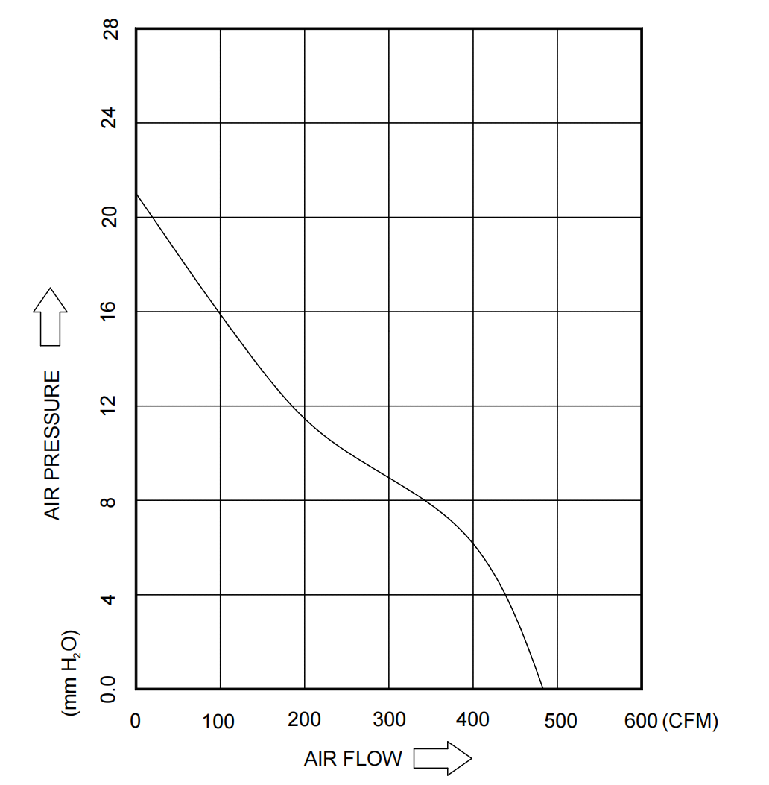
Charts : P-Q Curve

Dimensions Drawing :

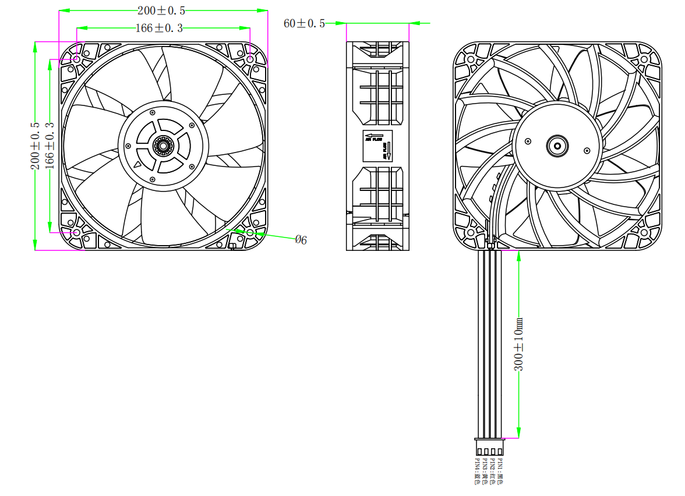

Notes:
UL1007 22AWG ,4-pin parallel wires(BK/RD/YE/BU) with
8821 white-housing terminalWire Length:300+/-10mm
PIN1: Black WIRE NEGATIVE (-) PIN2: Red WIRE POSITIVE (+)
PIN3:Yellow WIRE POSITIVE (FG) PIN4: Blue WIRE POSITIVE (PWM)

Confirm by sales team when placing sample order or bulk order
LABEL :
Warning:

1.The fan and motor must be used within the prescribed scope of temperature and humidity otherwise it will cause an unexpected damage.
2. Fan is not set wrong connection protection，Provide the right voltage and line sequence according to the nameplate otherwise it will damage the product.
3. Wiring depends on the wiring diagram and please connect the earth ground if required. We don't suggest to use the extension cord .Any wrong connection may cause the damage of the fan.
4. Be careful when moving the fan and do not take the blades as a handle because it will cause the distortion and chatter.
5. Connect the thermostat if required otherwise it would damage the motor because of the over temperature.
6. The length of the mounting screws shall not exceed the requirement, otherwise the fan will be damaged.
7. Do not disassemble the fan arbitrarily. It may hurt the capacity of water tightness and dynamic balance or cause other serious problems.
8. The over current protector is necessary in case the damage from the over current.
9. Install the fan as required, any other installing direction would affect the service life of the product.
10. The fan with inlet ring should be installed follow the requirements or it will affect the performance.
11. Users should use the standard cable when install the fan otherwise it will affect the water tightness.
12. The fan should keep away from the children especially the blade and electric parts .And the children are not allowed to operate the fan alone.
13. Do not connect the white signal cable directly to the red signal cable or the external DC power supply. Otherwise, the fan may be damaged.T
14.Please do not perform extraction and insertion of the connector under revolution irrespective of power on and power on and power off , and the fan should not touch or move when running.

15. Do not lift the fan wire when taking the fan, and do not impact the bearing during the handling process.
16. The version change may not be notified, please ask our company for the latest version when necessary.

17.Please be informed that we are not responsible for any damage or accidents caused by violating above rules to install and operate the fan.

Custom wire length
Approval
Note :Please check and mark the data when you sign the specification sheet .
Product Data Confirm :
0-10V
Speed Control System :

DATE :

CUSTOMER SIGNATURE:

CUSTOMER APPROVAL

