Ningbo Longwell Electric Technology CO.,LTD
NO.100, Ditang District, Yuyao, Zhejiang Province, China 315400
Phone 86 574 6218 9863
Fax 86 574 6218 9863
sales@zjlongwell.com
www.longwellfans.com

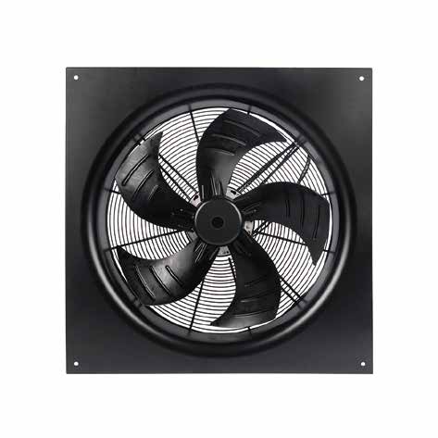

Model No.: | LWAE3G900TS-5PKW-04
Version Number: | A0
Make : | Jin
Review : | Zhong
Approvd : | Jiang
Date： | 2023.11.18

Version number | Notes Remarks | Reason content | Revised by | Date



Nominal Data

Project1 | Unit | Value
Nominal Voltage | [VAC] | 3-400
Voltage Range | [VAC] | 380~480
Frequency | [Hz] | 50/60
Speed | [rpm] | 1050±5%
Rated Current | [A] | 4.5±10%(5.6A MAX.)
Rated Power | [W] | 2766±10%
Maximum Input Power | [W] | 3404±10%
Air Flow (Max) | [m3/h] | 35962
Air Flow (Max) | [CFM] | 21154
Static Pressure (Max) | [Pa] | 464
Noise Level (LpAin) | dB(A) | 79
Max.Ambient Temp | ℃ | 65
Min.Ambient Temp | ℃ | -25
Insulation Class |  | Class F
Protection Type |  | IP54
Work System |  | S1

Production Reference Standard | GB12350《Safety requirements of small power motors》  JB/T10562 《 Technical specification for general purposes axial fans》  EN60335-1《Household and similar electrical appliances-safety》  ISO5801-1997《Industrial fans-performance testing using standardized airways》  GB/T2888《Methods of Noise Measurement for Fans Blowers Compressors and Roots Blowers》
Certification | CE
Environmental Protection | RoHS, Reach

Technical Features

Technical Features

Service Environment | Operating temperature：-25~65℃ ；Operating humidity：5 ~ 85% RH  Storing temperature：-35 ~ 75℃ ；Storing humidity：5 ~ 95% RH  Applicable altitude range: ＜1000m
Life Expectance | 40,000Hours(L10). At 40℃ room, humidity 15%~65%RH
Balancing | According to JB/T 9101-1999 requirements G6.3
Vibration Of The Fan | Test method accord with JB/T 8689
Installation Method | Horizontal or vertical installation
Material | Plastic (Impeller)
Bearing | Maintenance-free deep groove ball bearings
Weight | /

Electrical Protection

Speed Control | Control input 0~10VDC/PWM/4~20mA/RS485
VSP Control | Control signal VSP voltage range 1.5±0.1VDC~9.5±0.2VDC  (During normal operation, when the VSP voltage is below 0.8±0.1VDC, the motor switches from operating mode to standby mode)
PWM Control | PWM signal: frequency 0.1K～1KHz, amplitude 10～12V,duty cycle 0%～100% .
4-20mA Control | Input current for regulating speed 4-20mA(+0.2mA)/DC Control:  ≥20mA--n=max，4.5mA---n=min，≤3.2mA--n=0
Signal Output | Tach output：5 Pulse/R；Needs to increasing resistance to +10V/DC ( External power Max. 30V/DC), VFG=(5-30)VDC,R≥1000*(VFG)Ω
Auxiliary Power Output | Output 10±0.3VDC, Max Current: 22mA
Protection | Current limiting protection 、Over-temperature protection、Locked-rotor protection、Over/Under voltage protection、Open phase protection
Soft Start | Delay time <30 seconds to full speed
Serial Communication | LWRS485-05

3
The waterproof connector adapts to the cable size: minimum φ8mm, maximum φ12mm

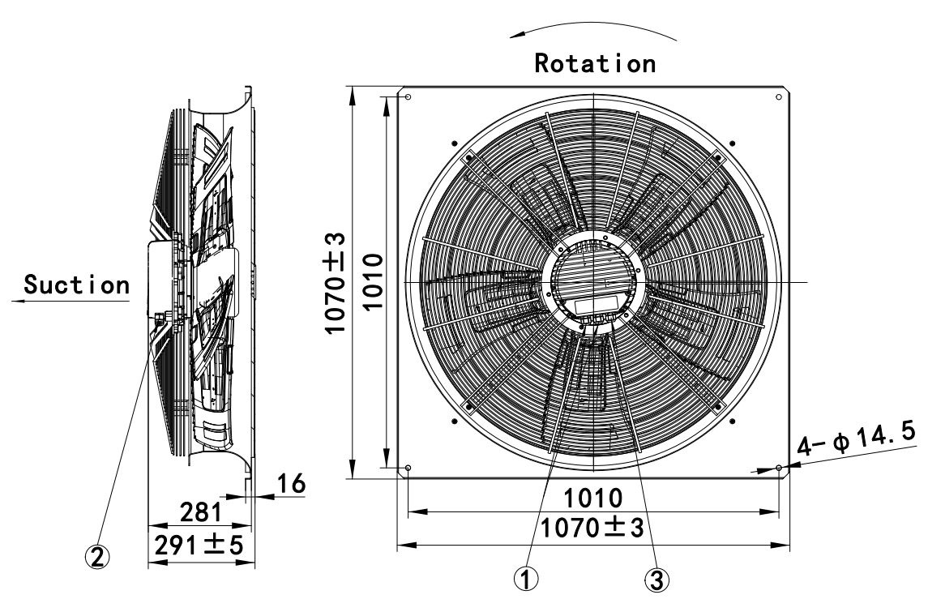

Product Drawing

2
M20 Torque/4.0N·m
The waterproof connector adapts to the cable size: minimum φ4mm, maximum φ8mm

1

Wiring Diagram

Label

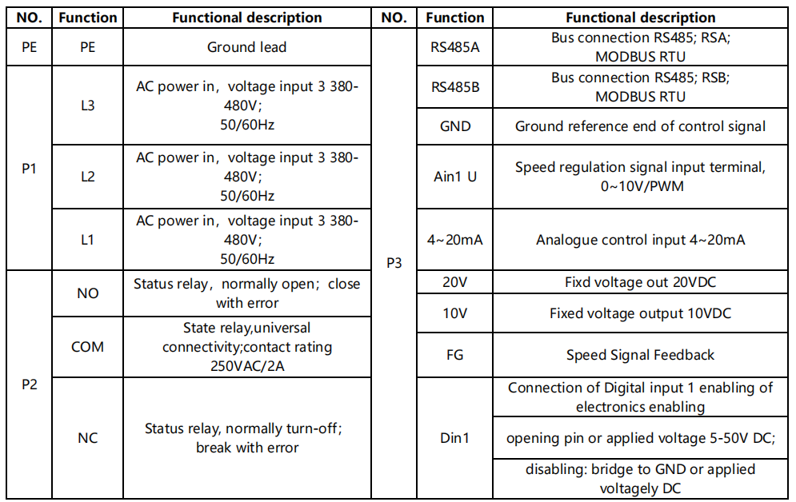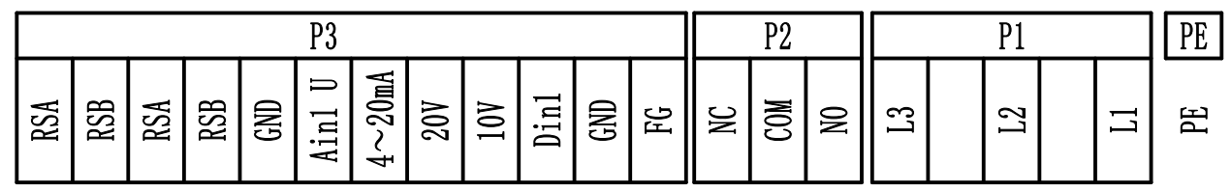

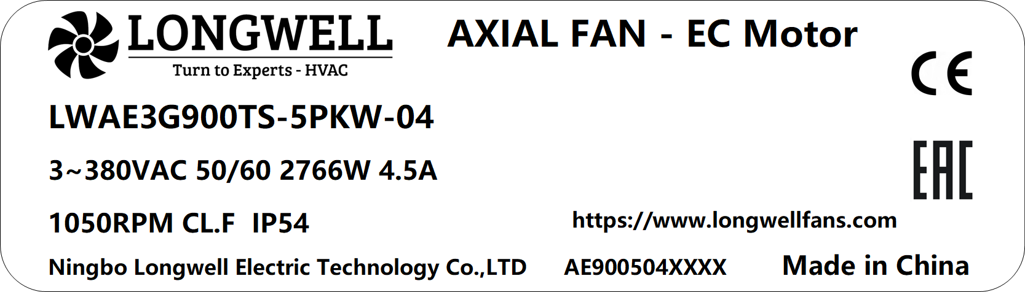

Charts :Air Flow (P-Q)

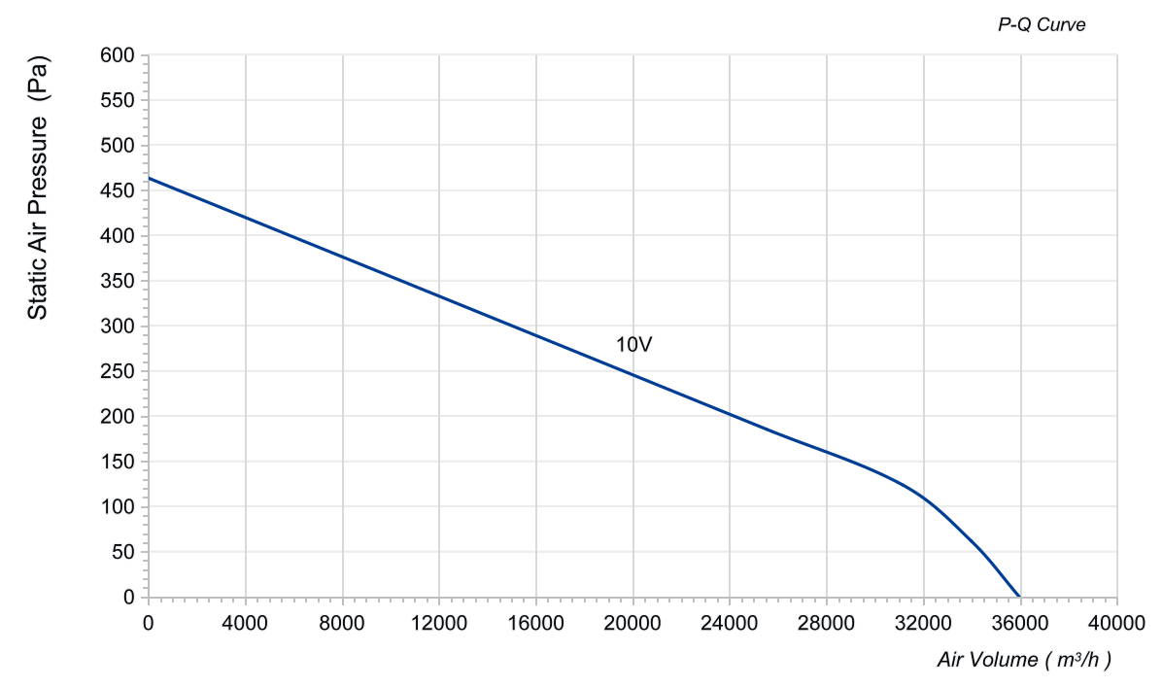

Confirm by sales team when placing sample order or bulk order
Label
VSP | Voltage  (V) | Speed  (RPM) | Power input  (W) | Airflow  (m³/h) | Static pressure  (Pa)
10V | 400 | 1050 | 2766 | 35962 | 0
10V | 400 | 1050 | 3016 | 33976 | 62
10V | 400 | 1050 | 3306 | 31160 | 124
10V | 400 | 1050 | 3404 | 25528 | 185

Warning:

1.The fan and motor must be used within the prescribed scope of temperature and humidity otherwise it will cause an unexpected damage.
2. Fan is not set wrong connection protection，Provide the right voltage and line sequence according to the nameplate otherwise it will damage the product.
3. Wiring depends on the wiring diagram and please connect the earth ground if required. We don't suggest to use the extension cord .Any wrong connection may cause the damage of the fan.
4. Be careful when moving the fan and do not take the blades as a handle because it will cause the distortion and chatter.
5. Connect the thermostat if required otherwise it would damage the motor because of the over temperature.
6. The length of the mounting screws shall not exceed the requirement, otherwise the fan will be damaged.
7. Do not disassemble the fan arbitrarily. It may hurt the capacity of water tightness and dynamic balance or cause other serious problems.
8. The over current protector is necessary in case the damage from the over current.
9. Install the fan as required, any other installing direction would affect the service life of the product.
10. The fan with inlet ring should be installed follow the requirements or it will affect the performance.
11. Users should use the standard cable when install the fan otherwise it will affect the water tightness.
12. The fan should keep away from the children especially the blade and electric parts .And the children are not allowed to operate the fan alone.
13. Do not connect the white signal cable directly to the red signal cable or the external DC power supply. Otherwise, the fan may be damaged.T
14.Please do not perform extraction and insertion of the connector under revolution irrespective of power on and power on and power off , and the fan should not touch or move when running.
15. Do not lift the fan wire when taking the fan, and do not impact the bearing during the handling process.
16. The version change may not be notified, please ask our company for the latest version when necessary.
- Please be informed that we are not responsible for any damage or accidents caused by violating above rules to install and operate the fan.
- The rated operating voltage of the fan is 3~400VA, the voltage range is 3~380-480VAC, the under-voltage protection is 320V, and the over-voltage protection is 520V.
- Motor over-temperature protection: When the temperature of the motor IPM module exceeds 105°C, the motor will stop after protection. When the temperature drops to 85°C, the motor automatically resumes operation.

Note: Please check and mark the data when you sign the specification sheet
4-20mA
Rs485
PWM
Approval
Product Data Confirm:
0-10V

Speed Control System:

DATE:

CUSTOMER SIGNATURE:

CUSTOMER APPROVAL

