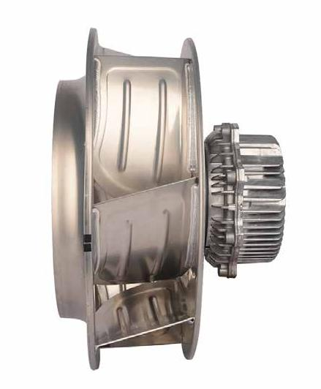

Ningbo Longwell Electric Technology CO.,LTD
NO.100, Ditang District ,Yuyao,Zhejiang Province,China 315400
Phone 86 574 6218 9863
Fax 86 574 6218 9863
sales@zjlongwell.com
www.longwellfans.com

Model No.: | LWBE3G250-102NS-20 A1
Version Number: | A0
Make : | Jin
Review : | Zhong
Approvd : | Yao
Date： | 20240530

Version number | Notes Remarks | Reason content | Revised by | Date



Nominal Data

Project1 | Unit | Rating
Nominal Voltage : | [VAC] | 230
Voltage Range : | [VAC] | 176~264
Frequency : | [Hz] | 50/60
Speed : | [rpm] | 4100
Current : | [A] | 3.9
Power input : | [W] | 750
Air flow (Max) : | [m3/h] | 3039
Air flow (Max) : | [CFM] | 1788
Static pressure ( Max) : | [Pa] | 1442
Noise level (LpAin ): | dB(A) | 93
Max.ambient Temp : | ℃ | 60
Min.ambient Temp : | ℃ | -25
Insulation Class : |  | Class F
Protection Type : |  | IP55
Work system : |  | S1

Technical Features
Production Reference standard | GB12350《Safety requirements of small power motors》  JB/T10563 《technical specification for general purposes centrifugal fans》  EN60335-1《Household and similar electrical appliances-safety》  ISO5801-1997《Industrial fans-performance testing using standardized airways》  GB/T2888《Methods of Noise Measurement for Fans Blowers Compressors and Roots Blowers》
Certification | CE  ETL (UL 507:2017 Ed.10+R:27May2020，CSA C22.2#113:2018 Ed.11）
Environmental protection | RoHS、Reach

Technical Features

Service environment | Operating temperature：-25~60℃；Operating humidity：5 ~ 90 % RH  Storing temperature：-40 ~ 80℃；Storing humidity：≤95 % RH  Applicable altitude range：＜1000m
Life Expectance | 40,000Hours(L10)，At 40℃ room, humidity 15%~65%RH.
Balancing | According to JB/T 9101-1999 requirements G6.3
Vibration of the fan | Test method accord with JB/T 8689
Installation method | Horizontal or vertical installation
Material | Aluminum Alloy ( Impeller )
Bearing | Maintenance-free deep groove ball bearings
Weight | APPROX 5.2 (Kg)

Speed Control | Control input 0~10VDC/PWM/RS485
VSP Control | Control signal VSP voltage range1±0.1VDC~10±0.2VDC  (During normal operation, when the VSP voltage is below 1.2VDC, the motor switches from operating mode to standby mode)
PWM Control | PWM signal: frequency 1K～10KHz, amplitude 10V,duty cycle 12%～100% .
Signal Output | Tach output：5 Pulse/R；FG internal open circuit output, external pull-up resistor R, pull-up voltage V+
Auxiliary power output | Output 10VDC，Max Current 10mA
Protection | Current limiting protection 、Over-temperature protection、Over-current protection  Locked-rotor protection
Soft start | Delay time <30 seconds to full speed
Serial Communication | LWRS485-02

Electrical Protection

Product Drawing

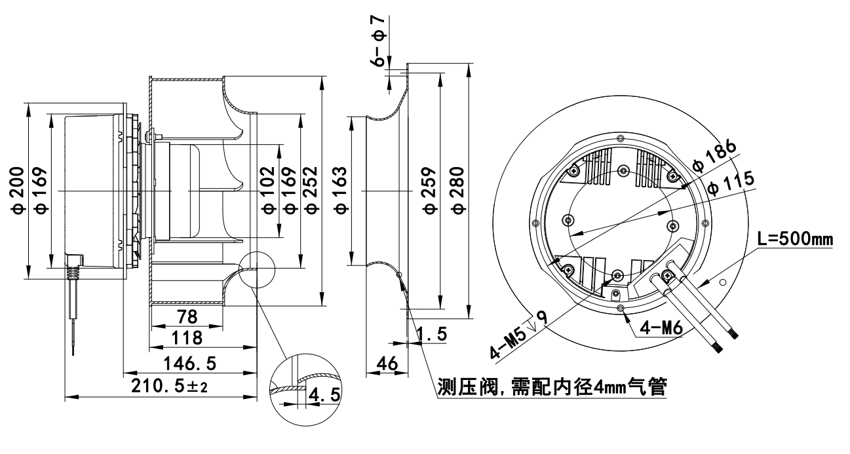

Wiring Diagram

Label

L | Color | Function | Functional description
L1 | Yellow/Green | PE | Ground lead
L1 | Brown | L | Live line
L1 | Black | N | Naught line
L1 | White | NC | Status relay, normally turn-off；break with error
L1 | Gray | COM | The normally closedterminal of the relay is closed with COMduring normal operation or not poweredon,when the fan fails,it is disconnectedfrom COM.
L2 | Brown | RS485A | Bus connection RS485; RSA;MODBUS RTU
L2 | Gray | RS485B | Bus connection RS485; RSB;MODBUS RTU
L2 | Yellow | Speed Control | Speed regulation signal input terminal,0-10VDC voltage /PWM
L2 | White | FG | Velocity feedback pulse output 5 Pulse/R
L2 | Red | +10VDC | Fixed voltage output 10VDC,Max 10mA
L2 | Blue | GND | Ground reference end of control signal

Confirm by sales team when placing sample order or bulk order

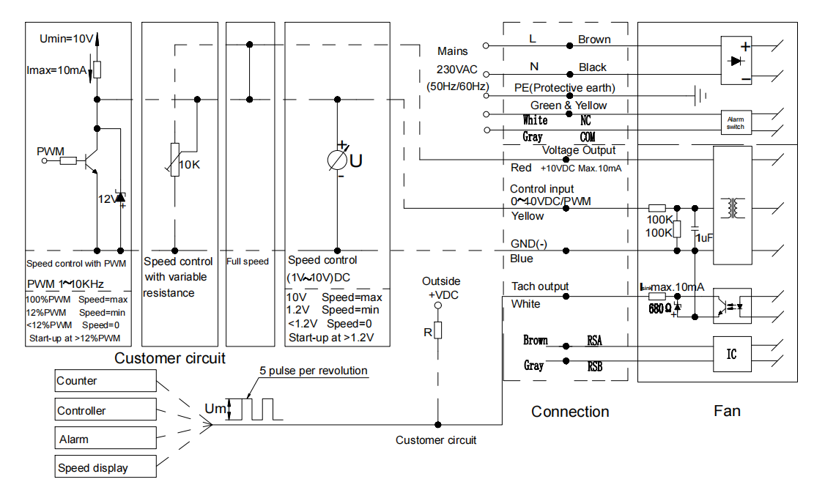
Wiring Diagram

Charts :Air Flow (P-Q)

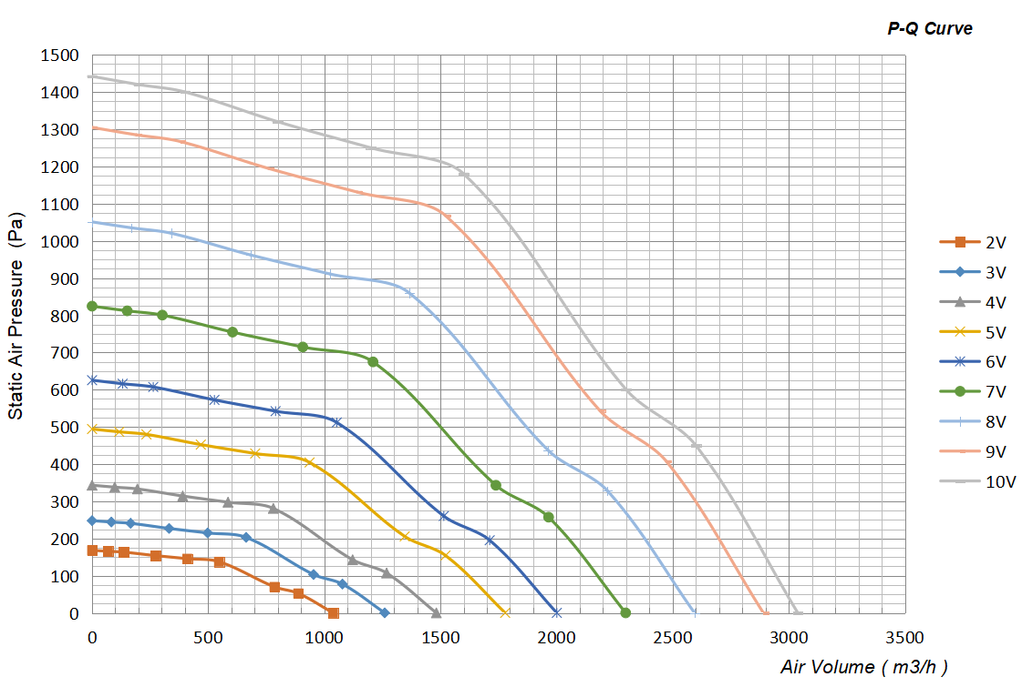

Confirm by sales team when placing sample order or bulk order
Label

VSP | Voltage  (V) | Power Input  (W) | Speed  (RPM) | Airflow  (m³/h) | Static Pressure  (Pa) | Current  (A)
10V | 230 | 750 | 4100 | 3039 | 0 | 3.9
10V | 230 | 750 | 4003 | 2600 | 450 | 3.9
10V | 230 | 750 | 3698 | 2300 | 600 | 3.9
10V | 230 | 750 | 3542 | 1600 | 1180 | 3.9
10V | 230 | 750 | 3543 | 1200 | 1250 | 3.9
10V | 230 | 750 | 3567 | 800 | 1320 | 3.9
10V | 230 | 750 | 3622 | 400 | 1400 | 3.9
10V | 230 | 750 | 3783 | 200 | 1420 | 3.9
10V | 230 | 750 | 3902 | 0 | 1442 | 3.9
9V | 230 | 670 | 4107 | 2891 | 0 | 3.6
9V | 230 | 670 | 3770 | 2473 | 407 | 3.6
9V | 230 | 670 | 3552 | 2188 | 543 | 3.6
9V | 230 | 670 | 3395 | 1522 | 1068 | 3.6
9V | 230 | 670 | 3383 | 1141 | 1131 | 3.6
9V | 230 | 670 | 3448 | 761 | 1194 | 3.6
9V | 230 | 670 | 3565 | 380 | 1267 | 3.6
9V | 230 | 670 | 3642 | 190 | 1285 | 3.6
9V | 230 | 670 | 3768 | 0 | 1305 | 3.6
8V | 230 | 495 | 3545 | 2594 | 0 | 2.7
8V | 230 | 495 | 3410 | 2220 | 328 | 2.7
8V | 230 | 495 | 3225 | 1963 | 437 | 2.7
8V | 230 | 495 | 3113 | 1366 | 860 | 2.7
8V | 230 | 495 | 3080 | 1024 | 911 | 2.7
8V | 230 | 495 | 3110 | 683 | 962 | 2.7
8V | 230 | 495 | 3170 | 341 | 1020 | 2.7
8V | 230 | 495 | 3348 | 171 | 1035 | 2.7
8V | 230 | 495 | 3398 | 0 | 1051 | 2.7

VSP | Voltage  (V) | Power Input  (W) | Speed  (RPM) | Airflow  (m³/h) | Static Pressure  (Pa) | Current  (A)
7V | 230 | 348 | 3105 | 2298 | 0 | 2.1
7V | 230 | 348 | 3048 | 1966 | 257 | 2.1
7V | 230 | 348 | 2820 | 1739 | 343 | 2.1
7V | 230 | 348 | 2723 | 1210 | 675 | 2.1
7V | 230 | 348 | 2685 | 907 | 715 | 2.1
7V | 230 | 348 | 2690 | 605 | 755 | 2.1
7V | 230 | 348 | 2767 | 302 | 800 | 2.1
7V | 230 | 348 | 2912 | 151 | 812 | 2.1
7V | 230 | 348 | 3008 | 0 | 824 | 2.1
6V | 230 | 240 | 2770 | 2001 | 0 | 1.5
6V | 230 | 240 | 2663 | 1712 | 195 | 1.5
6V | 230 | 240 | 2482 | 1515 | 260 | 1.5
6V | 230 | 240 | 2457 | 1054 | 512 | 1.5
6V | 230 | 240 | 2375 | 790 | 542 | 1.5
6V | 230 | 240 | 2393 | 527 | 572 | 1.5
6V | 230 | 240 | 2445 | 263 | 607 | 1.5
6V | 230 | 240 | 2607 | 132 | 616 | 1.5
6V | 230 | 240 | 2643 | 0 | 625 | 1.5
5V | 230 | 156 | 2363 | 1779 | 0 | 1.2
5V | 230 | 156 | 2215 | 1522 | 154 | 1.2
5V | 230 | 156 | 2182 | 1346 | 206 | 1.2
5V | 230 | 156 | 2035 | 937 | 404 | 1.2
5V | 230 | 156 | 2033 | 702 | 428 | 1.2
5V | 230 | 156 | 2083 | 468 | 452 | 1.2
5V | 230 | 156 | 2120 | 234 | 480 | 1.2
5V | 230 | 156 | 2212 | 117 | 487 | 1.2
5V | 230 | 156 | 2267 | 0 | 494 | 1.2

VSP | Voltage  (V) | Power Input  (W) | Speed  (RPM) | Airflow  (m³/h) | Static Pressure  (Pa) | Current  (A)
4V | 230 | 102 | 2030 | 1482 | 0 | 0.9
4V | 230 | 102 | 1907 | 1268 | 107 | 0.9
4V | 230 | 102 | 1718 | 1122 | 143 | 0.9
4V | 230 | 102 | 1732 | 780 | 281 | 0.9
4V | 230 | 102 | 1750 | 585 | 297 | 0.9
4V | 230 | 102 | 1827 | 390 | 314 | 0.9
4V | 230 | 102 | 1922 | 195 | 333 | 0.9
4V | 230 | 102 | 1940 | 98 | 338 | 0.9
4V | 230 | 102 | 2030 | 0 | 343 | 0.9
3V | 230 | 69 | 1973 | 1260 | 0 | 0.6
3V | 230 | 69 | 1718 | 1078 | 77 | 0.6
3V | 230 | 69 | 1600 | 954 | 103 | 0.6
3V | 230 | 69 | 1472 | 663 | 203 | 0.6
3V | 230 | 69 | 1470 | 498 | 215 | 0.6
3V | 230 | 69 | 1512 | 332 | 227 | 0.6
3V | 230 | 69 | 1577 | 166 | 241 | 0.6
3V | 230 | 69 | 1640 | 83 | 244 | 0.6
3V | 230 | 69 | 1973 | 0 | 248 | 0.6
2V | 230 | 48 | 1710 | 1038 | 0 | 0.6
2V | 230 | 48 | 1487 | 888 | 52 | 0.6
2V | 230 | 48 | 1405 | 785 | 70 | 0.6
2V | 230 | 48 | 1280 | 546 | 138 | 0.6
2V | 230 | 48 | 1295 | 410 | 146 | 0.6
2V | 230 | 48 | 1322 | 273 | 154 | 0.6
2V | 230 | 48 | 1415 | 137 | 163 | 0.6
2V | 230 | 48 | 1417 | 68 | 166 | 0.6
2V | 230 | 48 | 1400 | 0 | 168 | 0.6

Warning:

1.The fan and motor must be used within the prescribed scope of temperature and humidity otherwise it will cause an unexpected damage.
2. Fan is not set wrong connection protection，Provide the right voltage and line sequence according to the nameplate otherwise it will damage the product.
3. Wiring depends on the wiring diagram and please connect the earth ground if required. We don't suggest to use the extension cord .Any wrong connection may cause the damage of the fan.
4. Be careful when moving the fan and do not take the blades as a handle because it will cause the distortion and chatter.
5. Connect the thermostat if required otherwise it would damage the motor because of the over temperature.
6. The length of the mounting screws shall not exceed the requirement, otherwise the fan will be damaged.
7. Do not disassemble the fan arbitrarily. It may hurt the capacity of water tightness and dynamic balance or cause other serious problems.
8. The over current protector is necessary in case the damage from the over current.
9. Install the fan as required, any other installing direction would affect the service life of the product.
10. The fan with inlet ring should be installed follow the requirements or it will affect the performance.
11. Users should use the standard cable when install the fan otherwise it will affect the water tightness.
12. The fan should keep away from the children especially the blade and electric parts .And the children are not allowed to operate the fan alone.
13. Do not connect the white signal cable directly to the red signal cable or the external DC power supply. Otherwise, the fan may be damaged.T
14.Please do not perform extraction and insertion of the connector under revolution irrespective of power on and power on and power off , and the fan should not touch or move when running.

15. Do not lift the fan wire when taking the fan, and do not impact the bearing during the handling process.
16. The version change may not be notified, please ask our company for the latest version when necessary.

17.Please be informed that we are not responsible for any damage or accidents caused by violating above rules to install and operate the fan.

Rs485
Custom wire length
Pressure nozzle
Approval
Note :Please check and mark the data when you sign the specification sheet .
Product Data Confirm :
Air Inlet Cone
Accessories:
0-10V
PWM
Speed Control System :

DATE :

CUSTOMER SIGNATURE:

CUSTOMER APPROVAL

