Ningbo Longwell Electric Technology CO.,LTD
NO.100, Ditang District ,Yuyao,Zhejiang Province,China 315400
Phone 86 574 6218 9863
Fax 86 574 6218 9863
sales@zjlongwell.com
www.longwellfans.com

Model No.: | LWBE3G310-102NT-24-00
Version Number: | A0
Make : | Ye
Review : | Guo
Approvd : | Yao/Jiang
Date： | 20260702

Version number | Notes Remarks | Reason content | Revised by | Date



Nominal Data

Project1 | Unit | Rating
Nominal Voltage : | [VAC] | 380
Voltage Range : | [VAC] | 304~456
Frequency : | [Hz] | 50/60
Speed : | [rpm] | 3000
Current : | [A] | 1.8
Power input : | [W] | 1100
Air flow (Max) : | [m3/h] | 5150
Air flow (Max) : | [CFM] | 3029
Static pressure ( Max) : | [Pa] | 1730
Noise level (LpA ): | dB(A) | 85
Max.ambient Temp : | ℃ | 60
Min.ambient Temp : | ℃ | -25
Insulation Class : |  | Class F
Protection Type : |  | IP55
Work system : |  | S1

Technical Features
Production Reference standard | GB12350《Safety requirements of small power motors》  JB/T10563 《technical specification for general purposes centrifugal fans》  EN60335-1《Household and similar electrical appliances-safety》  ISO5801-1997《Industrial fans-performance testing using standardized airways》  GB/T2888《Methods of Noise Measurement for Fans Blowers Compressors and Roots Blowers》
Certification | CE
Environmental protection | RoHS、Reach

Technical Features

Service environment | Operating temperature：-25~60℃；Operating humidity：5 ~ 90 % RH  Storing temperature：-40 ~ 80℃；Storing humidity：≤95 % RH  Applicable altitude range：＜1000m
Life Expectance | 40,000Hours(L10)，At 40℃ room, humidity 15%~65%RH.
Balancing | According to JB/T 9101-1999 requirements G6.3
Vibration of the fan | Test method accord with JB/T 8689
Installation method | Horizontal or vertical installation
Material | Aluminum Alloy ( Impeller )
Bearing | Maintenance-free deep groove ball bearings
Weight | APPROX 5.5 (Kg)

Speed Control | Control input 0~10VDC/PWM/RS485
VSP Control | Control signal VSP voltage range1VDC~9.5VDC  (During normal operation, when the VSP voltage is below 0.8VDC, the motor switches from operating mode to standby mode)
PWM Control | PWM signal: frequency 1K～10KHz, amplitude 10V,duty cycle 10%～100% .
Signal Output | Tach output：5 Pulse/R；FG internal open circuit output, external pull-up resistor R, pull-up voltage V+
Auxiliary power output | Output 10VDC，Max Current 10mA
Protection | Current limiting protection 、Over-temperature protection、Over-current protection  Locked-rotor protection
Soft start | Delay time <30 seconds to full speed
Serial Communication | LWRS485-02

Electrical Protection

Product Drawing

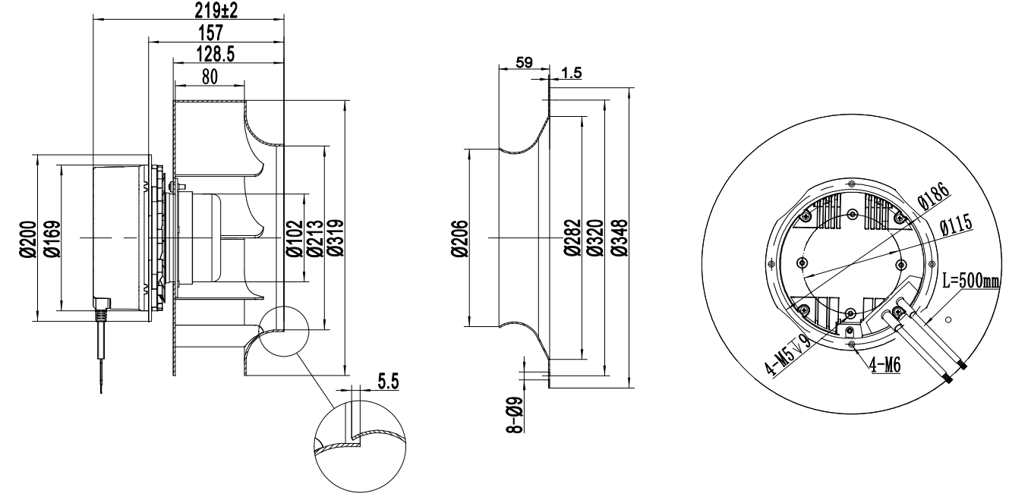

Wiring Diagram

Label

L | Color | Function | Functional description
L1 | Blue | L1 | Three-phase power supply terminalVoltage
L1 | Brown | L2 | Three-phase power supply terminalVoltage
L1 | Black | L3 | Three-phase power supply terminalVoltage
L1 | Yellow/Green | PE | Ground lead
L1 | White | NC | Status relay, normally turn-off；break with error
L1 | Gray | COM | The normally closedterminal of the relay is closed with COM during normal operation or not poweredon,when the fan fails,it is disconnected from COM.
L2 | Red | +10VDC | Fixed voltage output 10VDC,≦10mA
L2 | Blue | GND | Ground reference end of control signal
L2 | Yellow | Speed Control | Speed regulation signal input terminal,0-10VDC voltage /PWM
L2 | White | FG | Speed feedback pulse output
L2 | Brown | RS485A | Bus connection RS485; RSA;MODBUS RTU
L2 | Gray | RS485B | Bus connection RS485; RSB;MODBUS RTU

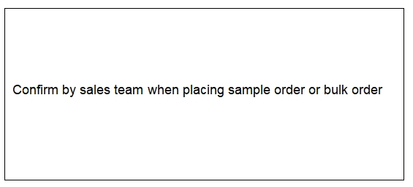

Charts :Air Flow (P-Q)

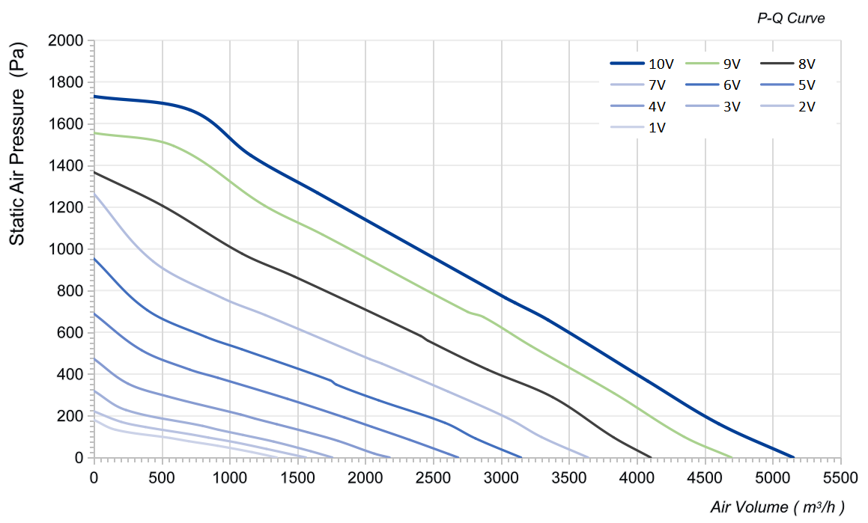

K-FACTOR：199
电流≦ mA不能用于***，上电顺序要求

Confirm by sales team when placing sample order or bulk order
Label
VSP | Speed(RPM) | Power input(W) | Airflow(m³/h) | Static pressure(Pa)
10V | 3867 | 1100 | 0 | 1730
10V | 3435 | 1100 | 708 | 1666
10V | 3227 | 1100 | 1157 | 1447
10V | 3037 | 1100 | 1647 | 1268
10V | 2848 | 1100 | 3033 | 764
10V | 2873 | 1100 | 3101 | 742
10V | 2858 | 1100 | 3345 | 659
10V | 2968 | 1100 | 4078 | 367
10V | 3177 | 1100 | 4602 | 162
10V | 3242 | 1100 | 5150 | 0

VSP | Speed(RPM) | Power input(W) | Airflow(m³/h) | Static pressure(Pa)
9V | 3718 | 939.0 | 0 | 1555
9V | 3295 | 939.0 | 587 | 1494
9V | 2998 | 939.0 | 1257 | 1207
9V | 2825 | 939.0 | 1684 | 1068
9V | 2730 | 939.0 | 2751 | 698
9V | 2700 | 939.0 | 2868 | 674
9V | 2743 | 939.0 | 3219 | 535
9V | 2867 | 939.0 | 3831 | 308
9V | 2968 | 939.0 | 4345 | 100
9V | 3075 | 939.0 | 4696 | 0
8V | 3363 | 678.0 | 0 | 1367
8V | 2930 | 678.0 | 506 | 1206
8V | 2680 | 678.0 | 1093 | 976
8V | 2575 | 678.0 | 1476 | 867
8V | 2438 | 678.0 | 2406 | 583
8V | 2415 | 678.0 | 2462 | 559
8V | 2478 | 678.0 | 2899 | 421
8V | 2553 | 678.0 | 3378 | 289
8V | 2672 | 678.0 | 3827 | 97
8V | 2698 | 678.0 | 4101 | 0
7V | 2982 | 474.0 | 0 | 1264
7V | 2618 | 474.0 | 436 | 940
7V | 2357 | 474.0 | 950 | 763
7V | 2253 | 474.0 | 1265 | 682
7V | 2148 | 474.0 | 2032 | 472
7V | 2157 | 474.0 | 2121 | 450
7V | 2198 | 474.0 | 2608 | 316
7V | 2282 | 474.0 | 3055 | 186
7V | 2342 | 474.0 | 3297 | 98
7V | 2423 | 474.0 | 3640 | 0

VSP | Speed(RPM) | Power input(W) | Airflow(m³/h) | Static pressure(Pa)
6V | 2592 | 315.0 | 0 | 953
6V | 2278 | 315.0 | 392 | 707
6V | 2047 | 315.0 | 826 | 578
6V | 1978 | 315.0 | 1087 | 519
6V | 1870 | 315.0 | 1740 | 370
6V | 1867 | 315.0 | 1786 | 349
6V | 1875 | 315.0 | 2097 | 274
6V | 1967 | 315.0 | 2587 | 166
6V | 2003 | 315.0 | 2810 | 92
6V | 2095 | 315.0 | 3145 | 0
5V | 2203 | 204.0 | 0 | 689
5V | 1922 | 204.0 | 352 | 514
5V | 1758 | 204.0 | 706 | 421
5V | 1692 | 204.0 | 913 | 382
5V | 1602 | 204.0 | 1426 | 281
5V | 1602 | 204.0 | 1843 | 193
5V | 1660 | 204.0 | 2047 | 147
5V | 1703 | 204.0 | 2323 | 85
5V | 1763 | 204.0 | 2610 | 18
5V | 1782 | 204.0 | 2682 | 0
4V | 1813 | 120.0 | 0 | 473
4V | 1610 | 120.0 | 250 | 354
4V | 1467 | 120.0 | 538 | 294
4V | 1330 | 120.0 | 1081 | 206
4V | 1313 | 120.0 | 1187 | 186
4V | 1328 | 120.0 | 1347 | 160
4V | 1347 | 120.0 | 1572 | 122
4V | 1385 | 120.0 | 1800 | 79
4V | 1457 | 120.0 | 2066 | 19
4V | 1485 | 120.0 | 2178 | 0

VSP | Speed(RPM) | Power input(W) | Airflow(m³/h) | Static pressure(Pa)
3V | 1492 | 75.0 | 0 | 319
3V | 1288 | 75.0 | 237 | 228
3V | 1108 | 75.0 | 802 | 151
3V | 1097 | 75.0 | 919 | 133
3V | 1103 | 75.0 | 1098 | 108
3V | 1140 | 75.0 | 1325 | 76
3V | 1192 | 75.0 | 1598 | 30
3V | 1228 | 75.0 | 1756 | 0
2V | 1248 | 48.0 | 0 | 221
2V | 1118 | 48.0 | 200 | 171
2V | 1038 | 48.0 | 379 | 146
2V | 948 | 48.0 | 711 | 111
2V | 930 | 48.0 | 842 | 96
2V | 933 | 48.0 | 1046 | 72
2V | 977 | 48.0 | 1271 | 41
2V | 1035 | 48.0 | 1562 | 0
1V | 1132 | 36.0 | 0 | 180
1V | 985 | 36.0 | 161 | 133
1V | 872 | 36.0 | 560 | 94
1V | 852 | 36.0 | 697 | 78
1V | 858 | 36.0 | 909 | 57
1V | 903 | 36.0 | 1165 | 26
1V | 948 | 36.0 | 1347 | 0

Warning:

1.The fan and motor must be used within the prescribed scope of temperature and humidity otherwise it will cause an unexpected damage.
2. Fan is not set wrong connection protection，Provide the right voltage and line sequence according to the nameplate otherwise it will damage the product.
3. Wiring depends on the wiring diagram and please connect the earth ground if required. We don't suggest to use the extension cord .Any wrong connection may cause the damage of the fan.
4. Be careful when moving the fan and do not take the blades as a handle because it will cause the distortion and chatter.
5. Connect the thermostat if required otherwise it would damage the motor because of the over temperature.
6. The length of the mounting screws shall not exceed the requirement, otherwise the fan will be damaged.
7. Do not disassemble the fan arbitrarily. It may hurt the capacity of water tightness and dynamic balance or cause other serious problems.
8. The over current protector is necessary in case the damage from the over current.
9. Install the fan as required, any other installing direction would affect the service life of the product.
10. The fan with inlet ring should be installed follow the requirements or it will affect the performance.
11. Users should use the standard cable when install the fan otherwise it will affect the water tightness.
12. The fan should keep away from the children especially the blade and electric parts .And the children are not allowed to operate the fan alone.
13. Do not connect the white signal cable directly to the red signal cable or the external DC power supply. Otherwise, the fan may be damaged.T
14.Please do not perform extraction and insertion of the connector under revolution irrespective of power on and power on and power off , and the fan should not touch or move when running.

15. Do not lift the fan wire when taking the fan, and do not impact the bearing during the handling process.
16. The version change may not be notified, please ask our company for the latest version when necessary.

17.Please be informed that we are not responsible for any damage or accidents caused by violating above rules to install and operate the fan.

Rs485
Custom wire length
Pressure nozzle
Approval
Note :Please check and mark the data when you sign the specification sheet .
Product Data Confirm :
Air Inlet Cone
Accessories:
0-10V
PWM
Speed Control System :

DATE :

CUSTOMER SIGNATURE:

CUSTOMER APPROVAL

