Ningbo Longwell Electric Technology CO.,LTD
NO.100, Ditang District, Yuyao, Zhejiang Province, China 315400
Phone 86 574 6218 9863
Fax 86 574 6218 9863
sales@zjlongwell.com
www.longwellfans.com

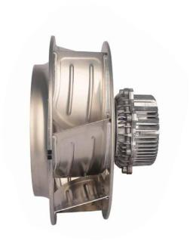

Model No.: | LWBE3G450-188NT-17
Version Number: | A0
Make : | Zhong
Review : | Jiang
Approvd : | Yao
Date： | 2023.11.09

Version number | Notes Remarks | Reason content | Revised by | Date



Nominal Data

Project1 | Unit | Value
Nominal Voltage | [VAC] | 3-380
Voltage Range | [VAC] | 304~456
Frequency | [Hz] | 50/60
Speed | [rpm] | 2800±5%
Rated Current | [A] | 5.3±10%
Rated Power | [W] | 2595±10%
Maximum Input Power | [W] | 4300±10%
Air Flow (Max) | [m3/h] | 8661
Air Flow (Max) | [CFM] | 5095
Static Pressure (Max) | [Pa] | 2114
Noise Level (LpAin) | dB(A) | /
Max.Ambient Temp | ℃ | 60
Min.Ambient Temp | ℃ | -25
Insulation Class |  | Class F
Protection Type |  | IP54
Work System |  | S1

Production Reference Standard | GB12350《Safety requirements of small power motors》  JB/T10563《technical specification for general purposes centrifugal fans》  EN60335-1《Household and similar electrical appliances-safety》  ISO5801-1997《Industrial fans-performance testing using standardized airways》  GB/T2888《Methods of Noise Measurement for Fans Blowers Compressors and Roots Blowers》
Certification | CE
Environmental Protection | RoHS, Reach

Technical Features

Technical Features

Service Environment | Operating temperature：-25~60℃ ；Operating humidity：0 ~ 85% RH  Storing temperature：-25 ~ 70℃ ；Storing humidity：0 ~ 95% RH  Applicable altitude range: ＜1000m
Life Expectance | 40,000Hours(L10). At 40℃ room, humidity 15%~65%RH
Balancing | According to JB/T 9101-1999 requirements G6.3
Vibration Of The Fan | Test method accord with JB/T 8689
Installation Method | Horizontal or vertical installation
Material | Aluminum Alloy (Impeller)
Bearing | Maintenance-free deep groove ball bearings
Weight | /

Speed Control | Control input 0~10VDC(RS485 external control box can be connected)
VSP Control | Control signal VSP voltage range 1.5±0.1VDC~9.5±0.2VDC  (During normal operation, when the VSP voltage is below 0.9±0.1VDC, the motor switches from operating mode to standby mode)
Signal Output | Tach output：15Pulse/R；FG internal open circuit output, external pull-up resistor 10K, pull-up voltage V+
Auxiliary Power Output | Output 10±0.3VDC, Max Current: 22mA
Protection | Current limiting protection, Over-temperature protection, Over-current protection  Locked-rotor protection, Input power supply lacks phase protection
Soft Start | Delay time <35 seconds to full speed
Serial Communication | LWRS485-04

Electrical Protection

Product Drawing

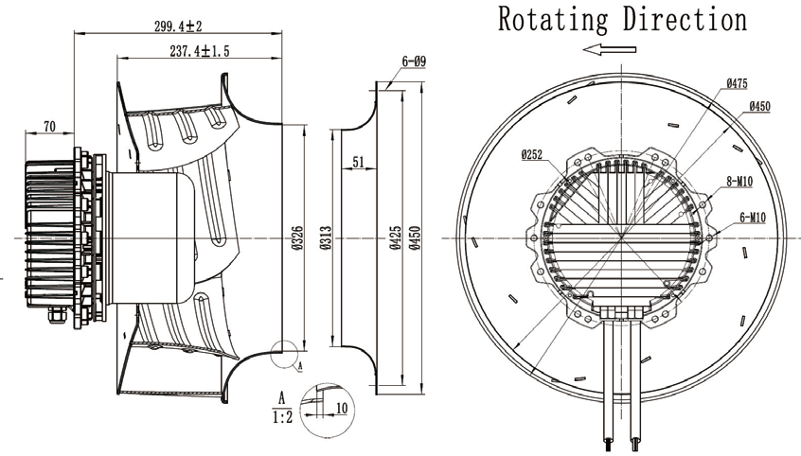
Note: The default line length is 1.5m.

Wiring Diagram

Label

L | Color | Function | Functional description | AWG
L1 | Yellow/Green | PE | Ground lead | UL21412 16AWG
L1 | Brown | U | Three-phase power supply terminal Voltage | UL21412 16AWG
L1 | Black | V | Three-phase power supply terminal Voltage | UL21412 16AWG
L1 | Blue | W | Three-phase power supply terminal Voltage | UL21412 16AWG
L2 | Orange | Speed Control | Speed regulation signal input terminal,0-10VDC voltage | UL2464 20AWG
L2 | Brown | FG | Velocity feedback pulse output 15 Pulse/R | UL2464 20AWG
L2 | Red | +10VDC | Fixed voltage output 10VDC | UL2464 20AWG
L2 | Black | GND | Ground reference end of control signal | UL2464 20AWG

Confirm by sales team when placing sample order or bulk order

Charts :Air Flow (P-Q)

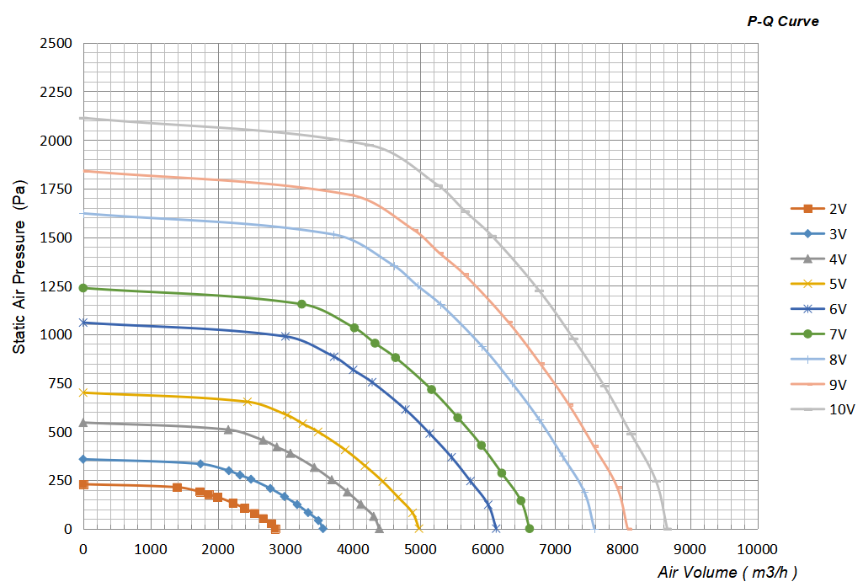

Confirm by sales team when placing sample order or bulk order
Label
VSP | Speed(RPM) | Power input(W) | Airflow(m³/h) | Static pressure(Pa)
10V | 2800 | 2593 | 8661 | 0
10V | 2800 | 2873 | 8495 | 246
10V | 2800 | 3240 | 8122 | 489
10V | 2800 | 3574 | 7727 | 734
10V | 2800 | 3851 | 7268 | 979
10V | 2800 | 4071 | 6760 | 1225
10V | 2800 | 4200 | 6061 | 1507
10V | 2800 | 4260 | 5663 | 1634
10V | 2800 | 4301 | 5261 | 1767
10V | 2800 | 4081 | 4238 | 1974
10V | 2800 | 2829 | 0 | 2114

VSP | Speed(RPM) | Power input(W) | Airflow(m³/h) | Static pressure(Pa)
9V | 2610 | 2100 | 8074 | 0
9V | 2610 | 2327 | 7918 | 213
9V | 2610 | 2624 | 7571 | 425
9V | 2610 | 2895 | 7203 | 638
9V | 2610 | 3119 | 6775 | 850
9V | 2610 | 3297 | 6301 | 1065
9V | 2610 | 3402 | 5649 | 1309
9V | 2610 | 3450 | 5278 | 1420
9V | 2610 | 3488 | 4905 | 1537
9V | 2610 | 3313 | 3953 | 1718
9V | 2610 | 2299 | 0 | 1841
8V | 2450 | 1737 | 7579 | 0
8V | 2450 | 1925 | 7433 | 188
8V | 2450 | 2171 | 7107 | 375
8V | 2450 | 2394 | 6761 | 562
8V | 2450 | 2580 | 6360 | 749
8V | 2450 | 2727 | 5915 | 938
8V | 2450 | 2814 | 5303 | 1154
8V | 2450 | 2854 | 4955 | 1251
8V | 2450 | 2885 | 4605 | 1354
8V | 2450 | 2741 | 3711 | 1514
8V | 2450 | 1902 | 0 | 1622
7V | 2140 | 1158 | 6620 | 0
7V | 2140 | 1283 | 6492 | 144
7V | 2140 | 1446 | 6207 | 286
7V | 2140 | 1596 | 5906 | 429
7V | 2140 | 1719 | 5555 | 572
7V | 2140 | 1817 | 5166 | 716
7V | 2140 | 1875 | 4632 | 880
7V | 2140 | 1902 | 4328 | 954
7V | 2140 | 1923 | 4022 | 1033
7V | 2140 | 1827 | 3242 | 1155
7V | 2140 | 1268 | 0 | 1238

VSP | Speed(RPM) | Power input(W) | Airflow(m³/h) | Static pressure(Pa)
6V | 1980 | 917 | 6125 | 0
6V | 1980 | 1016 | 6007 | 123
6V | 1980 | 1146 | 5743 | 245
6V | 1980 | 1264 | 5464 | 367
6V | 1980 | 1362 | 5140 | 489
6V | 1980 | 1440 | 4780 | 613
6V | 1980 | 1485 | 4286 | 753
6V | 1980 | 1506 | 4004 | 817
6V | 1980 | 1523 | 3722 | 885
6V | 1980 | 1447 | 3000 | 989
6V | 1980 | 1005 | 0 | 1060
5V | 1610 | 493 | 4980 | 0
5V | 1610 | 546 | 4884 | 81
5V | 1610 | 616 | 4670 | 162
5V | 1610 | 679 | 4443 | 243
5V | 1610 | 732 | 4179 | 324
5V | 1610 | 774 | 3887 | 405
5V | 1610 | 798 | 3485 | 498
5V | 1610 | 810 | 3256 | 540
5V | 1610 | 818 | 3025 | 584
5V | 1610 | 776 | 2437 | 653
5V | 1610 | 539 | 0 | 700
4V | 1420 | 338 | 4393 | 0
4V | 1420 | 375 | 4308 | 63
4V | 1420 | 423 | 4119 | 126
4V | 1420 | 466 | 3919 | 189
4V | 1420 | 502 | 3686 | 252
4V | 1420 | 531 | 3428 | 315
4V | 1420 | 548 | 3074 | 388
4V | 1420 | 556 | 2872 | 420
4V | 1420 | 562 | 2670 | 455
4V | 1420 | 535 | 2152 | 509
4V | 1420 | 371 | 0 | 546

VSP | Speed(RPM) | Power input(W) | Airflow(m³/h) | Static pressure(Pa)
3V | 1150 | 180 | 3557 | 0
3V | 1150 | 199 | 3489 | 41
3V | 1150 | 224 | 3336 | 83
3V | 1150 | 248 | 3174 | 124
3V | 1150 | 267 | 2985 | 165
3V | 1150 | 282 | 2776 | 207
3V | 1150 | 291 | 2489 | 254
3V | 1150 | 295 | 2326 | 276
3V | 1150 | 298 | 2161 | 298
3V | 1150 | 283 | 1741 | 333
3V | 1150 | 197 | 0 | 357
2V | 920 | 92 | 2846 | 0
2V | 920 | 102 | 2791 | 27
2V | 920 | 115 | 2669 | 53
2V | 920 | 127 | 2539 | 79
2V | 920 | 137 | 2388 | 106
2V | 920 | 144 | 2221 | 132
2V | 920 | 149 | 1991 | 163
2V | 920 | 151 | 1861 | 176
2V | 920 | 153 | 1728 | 191
2V | 920 | 145 | 1392 | 213
2V | 920 | 101 | 0 | 229

Warning:

1.The fan and motor must be used within the prescribed scope of temperature and humidity otherwise it will cause an unexpected damage.
2. Fan is not set wrong connection protection，Provide the right voltage and line sequence according to the nameplate otherwise it will damage the product.
3. Wiring depends on the wiring diagram and please connect the earth ground if required. We don't suggest to use the extension cord .Any wrong connection may cause the damage of the fan.
4. Be careful when moving the fan and do not take the blades as a handle because it will cause the distortion and chatter.
5. Connect the thermostat if required otherwise it would damage the motor because of the over temperature.
6. The length of the mounting screws shall not exceed the requirement, otherwise the fan will be damaged.
7. Do not disassemble the fan arbitrarily. It may hurt the capacity of water tightness and dynamic balance or cause other serious problems.
8. The over current protector is necessary in case the damage from the over current.
9. Install the fan as required, any other installing direction would affect the service life of the product.
10. The fan with inlet ring should be installed follow the requirements or it will affect the performance.
11. Users should use the standard cable when install the fan otherwise it will affect the water tightness.
12. The fan should keep away from the children especially the blade and electric parts .And the children are not allowed to operate the fan alone.
13. Do not connect the white signal cable directly to the red signal cable or the external DC power supply. Otherwise, the fan may be damaged.T
14.Please do not perform extraction and insertion of the connector under revolution irrespective of power on and power on and power off , and the fan should not touch or move when running.

15. Do not lift the fan wire when taking the fan, and do not impact the bearing during the handling process.
16. The version change may not be notified, please ask our company for the latest version when necessary.

17.Please be informed that we are not responsible for any damage or accidents caused by violating above rules to install and operate the fan.

Custom wire length
Pressure nozzle
Approval
Note: Please check and mark the data when you sign the specification sheet
Product Data Confirm:
Air Inlet Cone
Accessories:
0-10V

Speed Control System:

DATE:

CUSTOMER SIGNATURE:

CUSTOMER APPROVAL

