Ningbo Longwell Electric Technology CO.,LTD
NO.100, Ditang District ,Yuyao,Zhejiang Province,China 315400
Phone 86 574 6218 9863
Fax 86 574 6218 9863
sales@zjlongwell.com
www.longwellfans.com

Model No.: | LWBE3G500-188NT-10
Version Number: | A0
Make : | Zhong
Review : | Jiang
Approvd : | Yao
Date： | 2023.07.10

Version number | Notes Remarks | Reason content | Revised by | Date



Nominal Data

Project1 | Unit | Rating
Nominal Voltage : | [VAC] | 380
Voltage Range : | [VAC] | 304~456
Frequency : | [Hz] | 50/60
Speed : | [rpm] | 2200
Current : | [A] | 9.3
Power input : | [W] | 4270
Air flow (Max) : | [m3/h] | 13472
Air flow (Max) : | [CFM] | 7925
Static pressure ( Max) : | [Pa] | 1541
Noise level (LpA): | dB(A) | /
Max.ambient Temp : | ℃ | 60
Min.ambient Temp : | ℃ | -25
Insulation Class : |  | Class F
Protection Type : |  | IP54
Work system : |  | S1

Production Reference standard | GB12350《Safety requirements of small power motors》  JB/T10563 《technical specification for general purposes centrifugal fans》  EN60335-1《Household and similar electrical appliances-safety》  ISO5801-1997《Industrial fans-performance testing using standardized airways》  GB/T2888《Methods of Noise Measurement for Fans Blowers Compressors and Roots Blowers》
Certification | CE
Environmental protection | RoHS、Reach

Technical Features

Technical Features

Service environment | Operating temperature：-25~60℃；Operating humidity：0 ~ 85 % RH  Storing temperature：-40 ~ 70℃；Storing humidity：0 ~ 95 % RH  Applicable altitude range：＜1000m
Life Expectance | 40,000Hours(L10)，At 40℃ room, humidity 15%~65%RH.
Balancing | According to JB/T 9101-1999 requirements G6.3
Vibration of the fan | Test method accord with JB/T 8689
Installation method | Horizontal or vertical installation
Material | Aluminum Alloy ( Impeller )
Bearing | Maintenance-free deep groove ball bearings
Weight | /

Speed Control | Control input 0~10VDC/PWM/RS485
VSP Control | Control signal VSP voltage range1.0±0.1VDC~9.5±0.2VDC  (During normal operation, when the VSP voltage is below 0.9±0.1VDC, the motor switches from operating mode to standby mode)
PWM Control | PWM signal: frequency 1K～10KHz, amplitude 10～12V,duty cycle 0%～100% .
Signal Output | Tach output：15 Pulse/R；FG internal open circuit output, external pull-up resistor R, pull-up voltage V+
Auxiliary power output | Output 10±0.1VDC，Max Current≤22mA
Protection | Current limiting protection 、Over-temperature protection、Over-current protection  Locked-rotor protection’ 、 Input power supply lacks phase protection
Soft start | Delay time <35 seconds to full speed
Serial Communication | LWRS485-03

Electrical Protection

Product Drawing

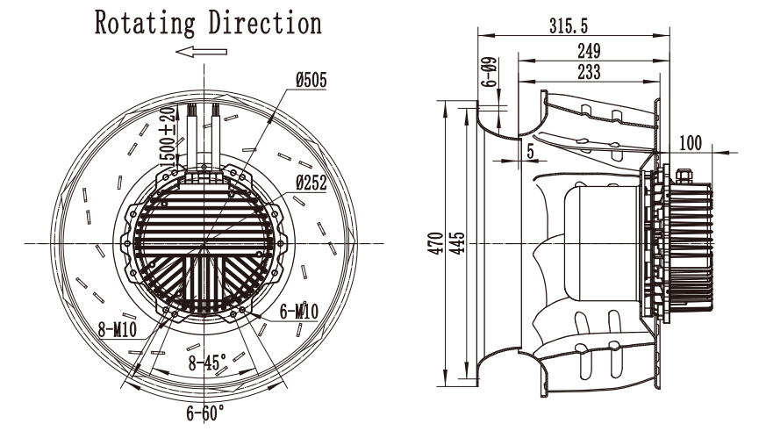

Wiring Diagram

Label

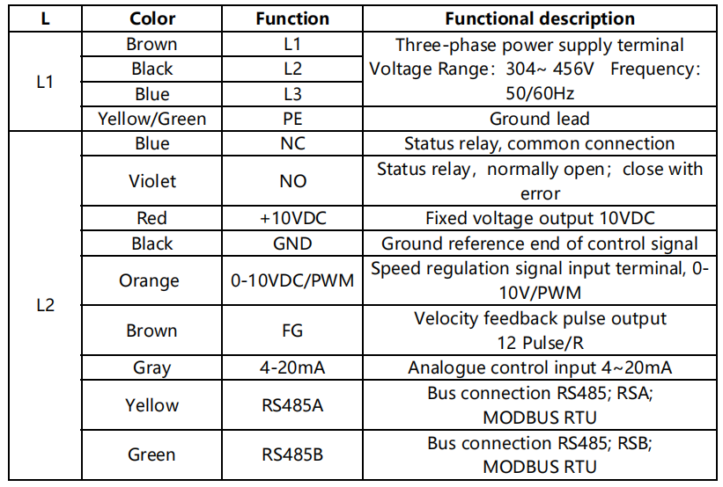

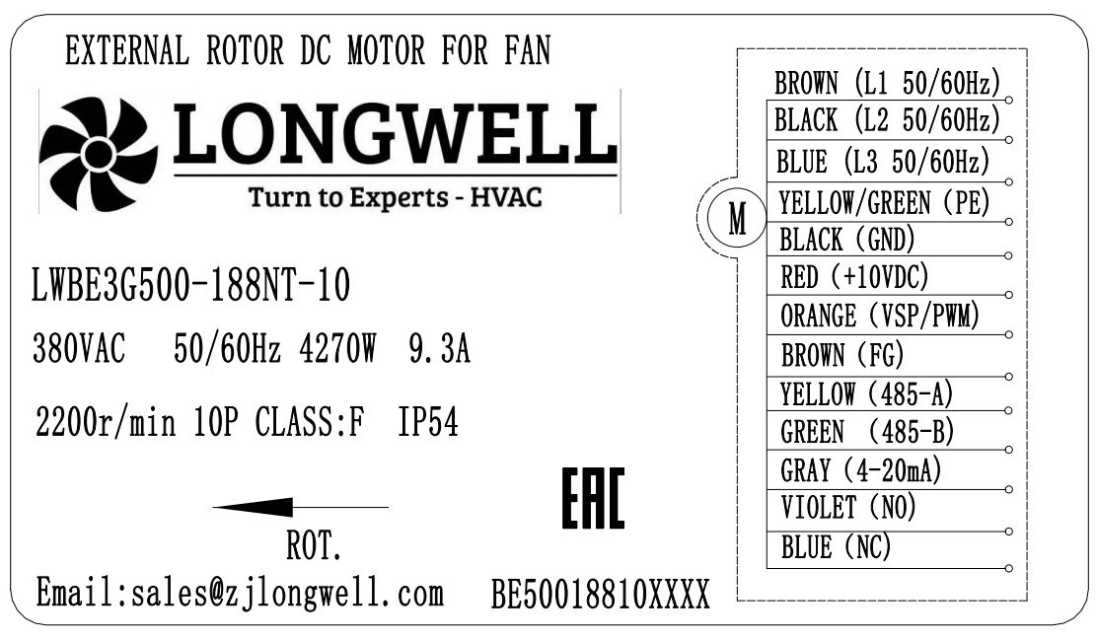

Charts :Air Flow (P-Q)

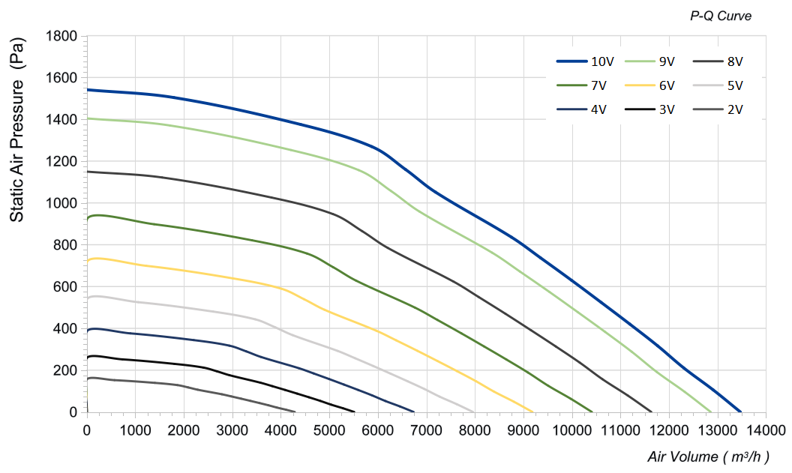

电流≦ mA不能用于***，上电顺序要求

Confirm by sales team when placing sample order or bulk order
Label
VSP | Speed(RPM) | Power input(W) | Airflow(m³/h) | Static pressure(Pa)
10V | 2200 | 4201 | 13472 | 0
10V | 2200 | 4262 | 12911 | 106
10V | 2200 | 4232 | 12308 | 210
10V | 2200 | 4238 | 11765 | 316
10V | 2200 | 4224 | 11191 | 421
10V | 2200 | 4238 | 10601 | 524
10V | 2200 | 4260 | 9993 | 630
10V | 2200 | 4218 | 9351 | 737
10V | 2200 | 4221 | 8752 | 836
10V | 2200 | 4259 | 7184 | 1052
10V | 2200 | 4270 | 6571 | 1160
10V | 2200 | 4239 | 5874 | 1269
10V | 2200 | 4253 | 4409 | 1375
10V | 2200 | 2930 | 1798 | 1504
10V | 2200 | 2257 | 0 | 1541

VSP | Speed(RPM) | Power input(W) | Airflow(m³/h) | Static pressure(Pa)
9V | 2100 | 3654 | 12859 | 0
9V | 2100 | 3707 | 12324 | 96
9V | 2100 | 3681 | 11749 | 191
9V | 2100 | 3686 | 11230 | 288
9V | 2100 | 3674 | 10682 | 383
9V | 2100 | 3686 | 10119 | 478
9V | 2100 | 3705 | 9539 | 574
9V | 2100 | 3669 | 8926 | 672
9V | 2100 | 3671 | 8354 | 762
9V | 2100 | 3704 | 6858 | 959
9V | 2100 | 3711 | 6272 | 1057
9V | 2100 | 3687 | 5607 | 1156
9V | 2100 | 3699 | 4209 | 1253
9V | 2100 | 2548 | 1716 | 1370
9V | 2100 | 1963 | 0 | 1404
8V | 1900 | 2706 | 11634 | 0
8V | 1900 | 2745 | 11150 | 79
8V | 1900 | 2726 | 10630 | 157
8V | 1900 | 2730 | 10161 | 236
8V | 1900 | 2721 | 9665 | 314
8V | 1900 | 2730 | 9155 | 391
8V | 1900 | 2744 | 8630 | 470
8V | 1900 | 2717 | 8076 | 550
8V | 1900 | 2719 | 7558 | 624
8V | 1900 | 2743 | 6204 | 785
8V | 1900 | 2749 | 5675 | 865
8V | 1900 | 2731 | 5073 | 947
8V | 1900 | 2740 | 3808 | 1026
8V | 1900 | 1887 | 1552 | 1122
8V | 1900 | 1454 | 0 | 1150

VSP | Speed(RPM) | Power input(W) | Airflow(m³/h) | Static pressure(Pa)
7V | 1700 | 1938 | 10410 | 0
7V | 1700 | 1966 | 9977 | 63
7V | 1700 | 1953 | 9511 | 125
7V | 1700 | 1955 | 9091 | 189
7V | 1700 | 1949 | 8648 | 251
7V | 1700 | 1955 | 8192 | 313
7V | 1700 | 1966 | 7722 | 376
7V | 1700 | 1946 | 7226 | 440
7V | 1700 | 1948 | 6763 | 499
7V | 1700 | 1965 | 5551 | 628
7V | 1700 | 1969 | 5078 | 692
7V | 1700 | 1956 | 4539 | 758
7V | 1700 | 1962 | 3407 | 821
7V | 1700 | 1352 | 1389 | 898
7V | 1700 | 1041 | 0 | 920
6V | 1500 | 1332 | 9185 | 0
6V | 1500 | 1351 | 8803 | 49
6V | 1500 | 1341 | 8392 | 98
6V | 1500 | 1343 | 8022 | 147
6V | 1500 | 1339 | 7630 | 195
6V | 1500 | 1343 | 7228 | 244
6V | 1500 | 1350 | 6813 | 293
6V | 1500 | 1337 | 6376 | 343
6V | 1500 | 1338 | 5967 | 389
6V | 1500 | 1350 | 4898 | 489
6V | 1500 | 1352 | 4480 | 539
6V | 1500 | 1344 | 4005 | 590
6V | 1500 | 1348 | 3006 | 639
6V | 1500 | 929 | 1226 | 699
6V | 1500 | 715 | 0 | 717

VSP | Speed(RPM) | Power input(W) | Airflow(m³/h) | Static pressure(Pa)
5V | 1300 | 867 | 7960 | 0
5V | 1300 | 879 | 7629 | 37
5V | 1300 | 873 | 7273 | 73
5V | 1300 | 874 | 6952 | 111
5V | 1300 | 872 | 6613 | 147
5V | 1300 | 874 | 6264 | 183
5V | 1300 | 879 | 5905 | 220
5V | 1300 | 870 | 5526 | 257
5V | 1300 | 871 | 5171 | 292
5V | 1300 | 879 | 4245 | 367
5V | 1300 | 880 | 3883 | 405
5V | 1300 | 875 | 3471 | 443
5V | 1300 | 878 | 2605 | 480
5V | 1300 | 605 | 1062 | 525
5V | 1300 | 466 | 0 | 538
4V | 1100 | 525 | 6736 | 6415
4V | 1100 | 533 | 6455 | 6148
4V | 1100 | 529 | 6154 | 5861
4V | 1100 | 530 | 5883 | 5603
4V | 1100 | 528 | 5595 | 5329
4V | 1100 | 530 | 5300 | 5048
4V | 1100 | 533 | 4996 | 4759
4V | 1100 | 527 | 4676 | 4453
4V | 1100 | 528 | 4376 | 4168
4V | 1100 | 532 | 3592 | 3421
4V | 1100 | 533 | 3285 | 3129
4V | 1100 | 530 | 2937 | 2797
4V | 1100 | 532 | 2204 | 2100
4V | 1100 | 366 | 899 | 856
4V | 1100 | 282 | 0 | 0

VSP | Speed(RPM) | Power input(W) | Airflow(m³/h) | Static pressure(Pa)
3V | 900 | 288 | 5511 | 0
3V | 900 | 292 | 5282 | 18
3V | 900 | 290 | 5035 | 35
3V | 900 | 290 | 4813 | 53
3V | 900 | 289 | 4578 | 70
3V | 900 | 290 | 4337 | 88
3V | 900 | 292 | 4088 | 105
3V | 900 | 289 | 3826 | 123
3V | 900 | 289 | 3580 | 140
3V | 900 | 292 | 2939 | 176
3V | 900 | 292 | 2688 | 194
3V | 900 | 290 | 2403 | 212
3V | 900 | 291 | 1804 | 230
3V | 900 | 201 | 735 | 252
3V | 900 | 155 | 0 | 258
2V | 700 | 135 | 4286 | 0
2V | 700 | 137 | 4108 | 11
2V | 700 | 136 | 3916 | 21
2V | 700 | 137 | 3743 | 32
2V | 700 | 136 | 3561 | 43
2V | 700 | 137 | 3373 | 53
2V | 700 | 137 | 3180 | 64
2V | 700 | 136 | 2975 | 75
2V | 700 | 136 | 2785 | 85
2V | 700 | 137 | 2286 | 107
2V | 700 | 137 | 2091 | 117
2V | 700 | 137 | 1869 | 128
2V | 700 | 137 | 1403 | 139
2V | 700 | 94 | 572 | 152
2V | 700 | 73 | 0 | 156

Warning:

1.The fan and motor must be used within the prescribed scope of temperature and humidity otherwise it will cause an unexpected damage.
2. Fan is not set wrong connection protection，Provide the right voltage and line sequence according to the nameplate otherwise it will damage the product.
3. Wiring depends on the wiring diagram and please connect the earth ground if required. We don't suggest to use the extension cord .Any wrong connection may cause the damage of the fan.
4. Be careful when moving the fan and do not take the blades as a handle because it will cause the distortion and chatter.
5. Connect the thermostat if required otherwise it would damage the motor because of the over temperature.
6. The length of the mounting screws shall not exceed the requirement, otherwise the fan will be damaged.
7. Do not disassemble the fan arbitrarily. It may hurt the capacity of water tightness and dynamic balance or cause other serious problems.
8. The over current protector is necessary in case the damage from the over current.
9. Install the fan as required, any other installing direction would affect the service life of the product.
10. The fan with inlet ring should be installed follow the requirements or it will affect the performance.
11. Users should use the standard cable when install the fan otherwise it will affect the water tightness.
12. The fan should keep away from the children especially the blade and electric parts .And the children are not allowed to operate the fan alone.
13. Do not connect the white signal cable directly to the red signal cable or the external DC power supply. Otherwise, the fan may be damaged.T
14.Please do not perform extraction and insertion of the connector under revolution irrespective of power on and power on and power off , and the fan should not touch or move when running.

15. Do not lift the fan wire when taking the fan, and do not impact the bearing during the handling process.
16. The version change may not be notified, please ask our company for the latest version when necessary.

17.Please be informed that we are not responsible for any damage or accidents caused by violating above rules to install and operate the fan.

Rs485
Custom wire length
Pressure nozzle
Approval
Note :Please check and mark the data when you sign the specification sheet .
Product Data Confirm :
Air Inlet Cone
Accessories:
0-10V
PWM
Speed Control System :

DATE :

CUSTOMER SIGNATURE:

CUSTOMER APPROVAL

