Ningbo Longwell Electric Technology CO.,LTD
NO.100, Ditang District, Yuyao, Zhejiang Province, China 315400
Phone 86 574 6218 9863
Fax 86 574 6218 9863
sales@zjlongwell.com
www.longwellfans.com

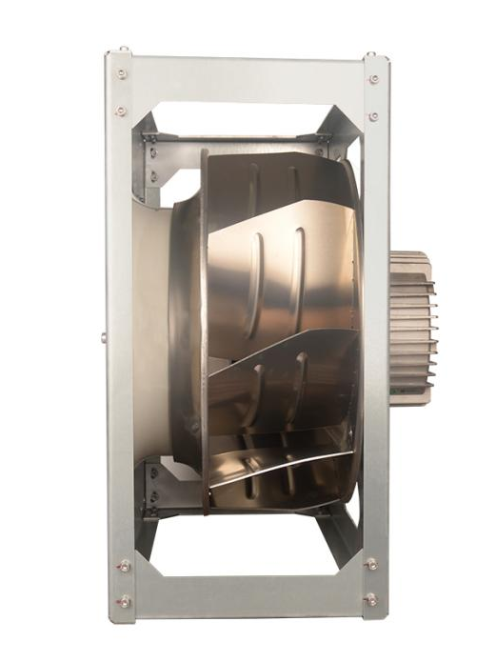

Model No.: | LWBE3G560-188PT-08
Version Number: | A0
Make : | Xia
Review : | Zhong
Approvd : | Jiang
Date： | 2024.01.16

Version number | Notes Remarks | Reason content | Revised by | Date



Nominal Data

Project1 | Unit | Value
Nominal Voltage | [VAC] | 3-380
Voltage Range | [VAC] | 320~480
Frequency | [Hz] | 50/60
Speed | [rpm] | 1850±100%
Rated Current | [A] | 7.9±10%
Rated Power | [W] | 4700±10%
Maximum Input Power | [W] | 5600
Air Flow (Max) | [m3/h] | 19760
Air Flow (Max) | [CFM] | 11624
Static Pressure (Max) | [Pa] | 1545
Noise Level (LpAin) | dB(A) | 91
Max.Ambient Temp | ℃ | 60
Min.Ambient Temp | ℃ | -25
Insulation Class |  | Class F
Protection Type |  | IP54
Work System |  | S1

Production Reference Standard | GB12350《Safety requirements of small power motors》  JB/T10563《technical specification for general purposes centrifugal fans》  EN60335-1《Household and similar electrical appliances-safety》  ISO5801-1997《Industrial fans-performance testing using standardized airways》  GB/T2888《Methods of Noise Measurement for Fans Blowers Compressors and Roots Blowers》
Certification | CE
Environmental Protection | RoHS, Reach

Technical Features

Technical Features

Service Environment | Operating temperature：-25~60℃ ；Operating humidity：30 ~ 95% RH  Storing temperature：-40 ~ 80℃ ；Storing humidity：30 ~ 95% RH  Applicable altitude range: ＜1000m
Life Expectance | 40,000Hours(L10). At 40℃ room, humidity 15%~65%RH
Balancing | According to JB/T 9101-1999 requirements G6.3
Vibration Of The Fan | Test method accord with JB/T 8689
Installation Method | Horizontal or vertical installation
Material | Aluminum Alloy (Impeller)
Bearing | Maintenance-free deep groove ball bearings
Weight | 67Kg

Speed Control | Control input 0~10VDC / PWM / RS485
VSP Control | Control signal VSP voltage range1±0.1VDC~9.5±0.2VDC  (During normal operation, when the VSP voltage is below 1.0±0.1VDC, the motor switches from operating mode to standby mode)
PWM Control | PWM signal: frequency 1K～10KHz, amplitude 10～12V,duty cycle 30%～70% .
Signal Output | Tach output:12 Pulse/R；FG internal open circuit output, external pull-up resistor 10KΩ, pull-up voltage +10V
Auxiliary power output | Output 10VDC，Max Current 10 mA
Protection | Over-temperature protection、Over-current protection、Locked-rotor protection’
Soft start | Delay time <30 seconds to full speed
Serial Communication | LWRS485-01

Electrical Protection

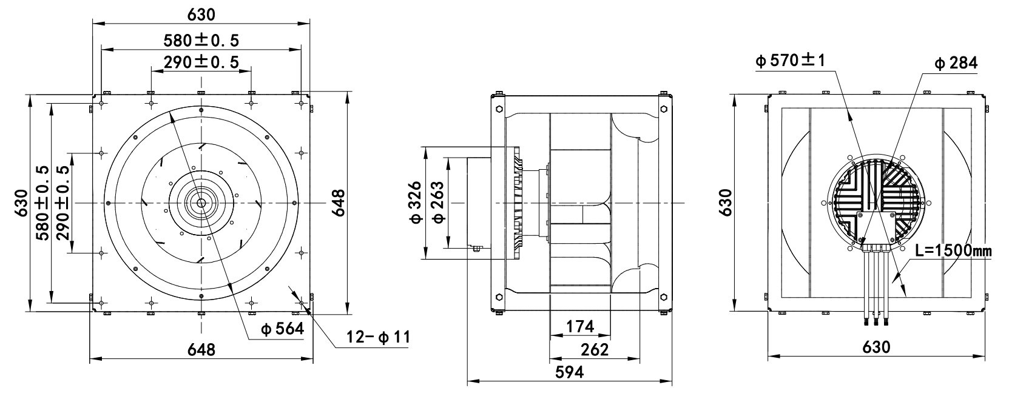
Product Drawing

Wiring Diagram

Label

L | Color | Function | Functional description
L1 | Yellow/Green | PE | Ground lead
L1 | Black | L1 | Three-phase power supply terminal Voltage
L1 | Black | L2 | Three-phase power supply terminal Voltage
L1 | Black | L3 | Three-phase power supply terminal Voltage
L2 | Yellow | Speed Control | Speed regulation signal input terminal,0-10VDC voltage / PWM
L2 | White | FG | Velocity feedback pulse output 12 Pulse/R
L2 | Red | +10VDC | Fixed voltage output 10VDC
L2 | Blue | GND | Ground reference end of control signal
L2 | Brown | RS485A | Bus connection RS485; RSA;MODBUS RTU
L2 | Black | RS485B | Bus connection RS485; RSB;MODBUS RTU
L3 | Brown | NO | Status relay，normally open；close with error
L3 | Black | COM | The normally closedterminal of the relay is closed with COMduring normal operation or not poweredon,when the fan fails,it is disconnectedfrom COM.
L3 | Orange | NC | Status relay, normally turn-off；break with error

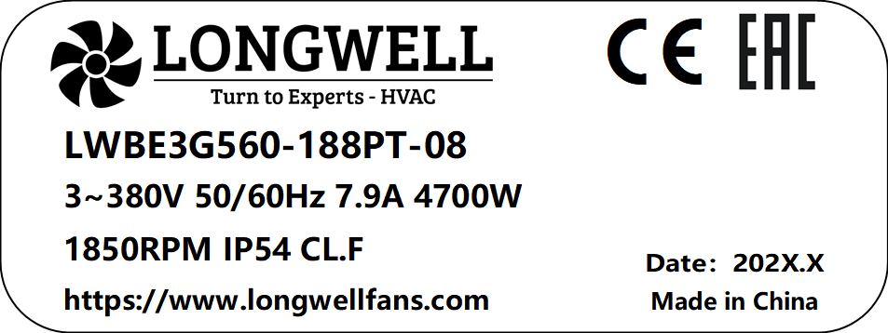

Charts :Air Flow (P-Q)

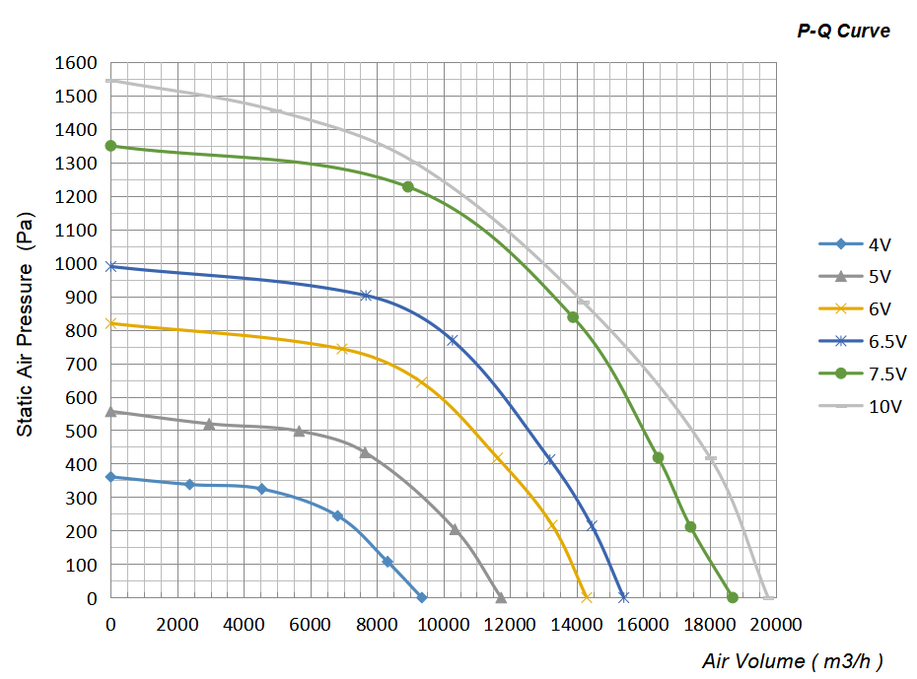

Confirm by sales team when placing sample order or bulk order
Label
VSP | Voltage  (V) | Power Input  (W) | Speed  (RPM) | Airflow  (m³/h) | Static Pressure  (Pa) | Current  (A) | Efficiency  Value  (%)
10V | 380 | 4700 | 1823 | 19760 | 0 | 7.90 | 0%
10V | 380 | 5500 | 1828 | 18020 | 417 | 8.92 | 38%
10V | 380 | 5576 | 1723 | 14198 | 883 | 9.00 | 62%
10V | 380 | 5534 | 1750 | 9147 | 1299 | 9.41 | 60%
10V | 380 | 4588 | 1823 | 4953 | 1454 | 8.04 | 44%
7.5V | 380 | 3730 | 1700 | 18692 | 0 | 6.10 | 0%
7.5V | 380 | 4051 | 1700 | 17429 | 211 | 6.57 | 25%
7.5V | 380 | 4552 | 1700 | 16454 | 418 | 7.39 | 42%
7.5V | 380 | 5163 | 1700 | 13894 | 837 | 8.36 | 63%
7.5V | 380 | 4981 | 1700 | 8935 | 1227 | 8.16 | 61%

VSP | Voltage  (V) | Power Input  (W) | Speed  (RPM) | Airflow  (m³/h) | Static Pressure  (Pa) | Current  (A) | Efficiency  Value  (%)
6.5 | 380 | 2087 | 1433 | 15421 | 0 | 3.45 | 0%
6.5 | 380 | 2594 | 1437 | 14460 | 214 | 4.26 | 33%
6.5 | 380 | 2934 | 1441 | 13200 | 412 | 4.79 | 51%
6.5 | 380 | 3363 | 1454 | 10271 | 768 | 5.49 | 65%
6.5 | 380 | 3129 | 1453 | 7671 | 902 | 5.08 | 61%
6V | 380 | 1686 | 1325 | 14305 | 0 | 2.85 | 0%
6V | 380 | 2147 | 1327 | 13269 | 216 | 3.54 | 37%
6V | 380 | 2398 | 1324 | 11628 | 417 | 3.92 | 56%
6V | 380 | 2558 | 1324 | 9345 | 643 | 4.21 | 65%
6V | 380 | 2348 | 1323 | 6954 | 743 | 3.84 | 61%
5V | 380 | 971 | 1092 | 11735 | 0 | 1.69 | 0%
5V | 380 | 1286 | 1093 | 10346 | 204 | 2.21 | 46%
5V | 380 | 1450 | 1095 | 7644 | 434 | 2.46 | 64%
5V | 380 | 1312 | 1083 | 5661 | 497 | 2.23 | 60%
5V | 380 | 978 | 1089 | 2958 | 519 | 1.71 | 44%
4V | 380 | 525 | 874 | 9350 | 0 | 1.00 | 0%
4V | 380 | 654 | 874 | 8320 | 107 | 1.23 | 38%
4V | 380 | 767 | 874 | 6820 | 244 | 1.39 | 60%
4V | 380 | 713 | 874 | 4543 | 324 | 1.30 | 57%
4V | 380 | 536 | 876 | 2374 | 338 | 1.02 | 42%

Warning:

1.The fan and motor must be used within the prescribed scope of temperature and humidity otherwise it will cause an unexpected damage.
2. Fan is not set wrong connection protection，Provide the right voltage and line sequence according to the nameplate otherwise it will damage the product.
3. Wiring depends on the wiring diagram and please connect the earth ground if required. We don't suggest to use the extension cord .Any wrong connection may cause the damage of the fan.
4. Be careful when moving the fan and do not take the blades as a handle because it will cause the distortion and chatter.
5. Connect the thermostat if required otherwise it would damage the motor because of the over temperature.
6. The length of the mounting screws shall not exceed the requirement, otherwise the fan will be damaged.
7. Do not disassemble the fan arbitrarily. It may hurt the capacity of water tightness and dynamic balance or cause other serious problems.
8. The over current protector is necessary in case the damage from the over current.
9. Install the fan as required, any other installing direction would affect the service life of the product.
10. The fan with inlet ring should be installed follow the requirements or it will affect the performance.
11. Users should use the standard cable when install the fan otherwise it will affect the water tightness.
12. The fan should keep away from the children especially the blade and electric parts .And the children are not allowed to operate the fan alone.
13. Do not connect the white signal cable directly to the red signal cable or the external DC power supply. Otherwise, the fan may be damaged.T
14.Please do not perform extraction and insertion of the connector under revolution irrespective of power on and power on and power off , and the fan should not touch or move when running.

15. Do not lift the fan wire when taking the fan, and do not impact the bearing during the handling process.
16. The version change may not be notified, please ask our company for the latest version when necessary.

17.Please be informed that we are not responsible for any damage or accidents caused by violating above rules to install and operate the fan.

Rs485
PWM
Custom wire length
Pressure nozzle
Approval
Note: Please check and mark the data when you sign the specification sheet
Product Data Confirm:
Air Inlet Cone
Accessories:
0-10V

Speed Control System:

DATE:

CUSTOMER SIGNATURE:

CUSTOMER APPROVAL

