Ningbo Longwell Electric Technology CO.,LTD
Yuyao,Zhejiang Province,China 315400
Phone 86 574 6218 9863
Fax 86 574 6218 9863
sales@zjlongwell.com
www.longwellfans.com

Normal Parameters

Model |  | LWCA-30150SN-07
Nominal Voltage : | [VAC] | 230V
Voltage Range : | [VAC] | 198~242
Rated speed： | [rpm] | 2400±10%
Frequency : | [Hz] | 50
Power input : | [W] | 10
Air flow (Max) : | [m3/h] | 38
Air flow (Max) : | [CFM] | 22
Static pressure ( Max) : | [Pa] | 9
Noise level : | dB(A) | 25
Min.ambient Temp : | ℃ | -10
Max.ambient Temp : | ℃ | + 65
Bearing Type： | / | Ball Bearing
Motor | / | LW48-15

Material : | Aluminium ( Impeller )； Iron（frame）
Surface treatment: | Volute black electrophoresis
Life Expectance : | 50,000Hours(L10)，At 20℃ room, humidity 15%~65%RH
Service environment : | Operating temperature：-10~85℃；Operating humidity：5 ~ 90 % RH  Storing temperature：0~65℃；Storing humidity：0 ~ 90 % RH
Insulation Class : | Class F（155℃)
Insulation Resistance： | Cold resistance between stator core and winding is more than 50 m Ω . (using DC500V  Meg-ohmmeter to test).
Pressure test: | Motor run 1 seconds, under 1800V/ 2mA ,no breakdown and flash-over.
Protected Mode: | Z.P impedance protection.

Electrical Protection

Technical Features

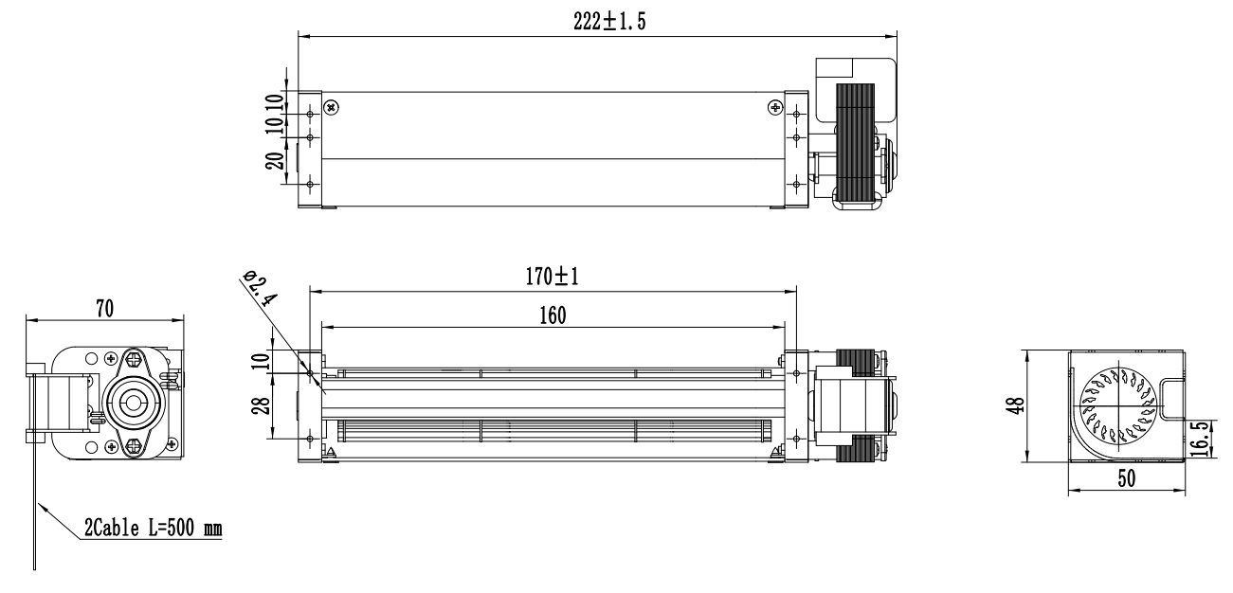
Product Drawing
Charts :Air Flow

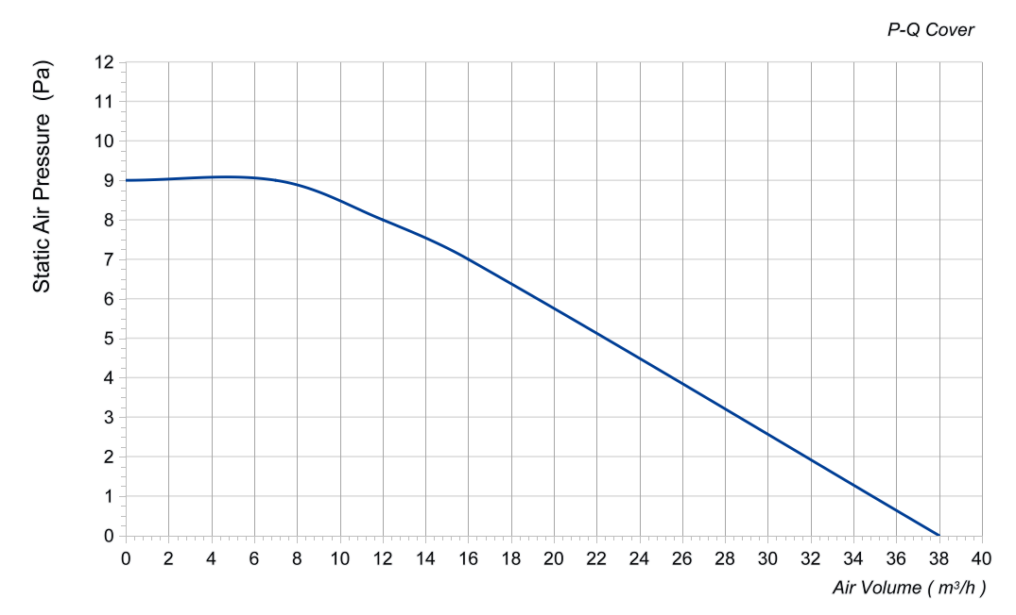

Confirm by sales team when placing sample order or bulk order
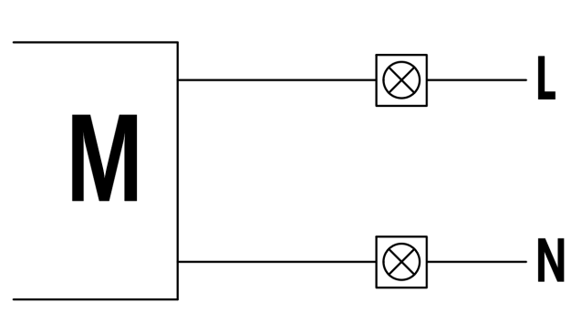
Label
Wiring Diagram

警示语 ：Warning
1.电机、风机必须在规定的温度和湿度范围内使用，否则可能造成不可预测的损坏。 使用时请勿超出以上规格书所规定之极限，否则我们不保证此产品。
The fan and motor must be used within the prescribed scope of temperature and humidity otherwise it will cause an
unexpected damage. We will not guarantee the products if the applications of our products are exceeded the
limitation which is specified on this specification.
2.请务必使用铭牌指示的正确电压接入产品，否则会造成风机损坏。
Provide the right voltage according to the nameplate otherwise it will damage the product.
3.电机接线必须按接线图的指示，有接地线要求的产品请务必接上地线，不建议客户使用延长线，所有不按指示
接线都可能造成电机烧坏。
Wiring depends on the wiring diagram and please connect the earth ground if required. We don't suggest to use the
extension cord .Any wrong connection may cause the damage of the fan.
4.请勿触压着叶片以及电源线绕着风扇或用力拉扯电源线，如此轴心与电源线将会被损坏。
Please do not touch the blade with the push and never bring the fan with lead wire, the bearing and lead wire may be damaged.
5.本产品不保证因粉尘、水滴、小虫进入，而影响寿命与不良品产生。
No guarantee on the products against the safety problem or failure covers by power dust drop of water or insect.6. 6.使用的安装螺丝不得超过要求长度，否则会造成风机损坏。
The length of the mounting screws shall not exceed the requirement, otherwise the fan will be damaged.
7.请不要自主拆装风机，否则将影响扇叶平衡、防水等效果，严重的将引起安全问题。
Do not disassemble the fan arbitrarily. It may hurt the capacity of water tightness and dynamic balance or cause other serious problems.
8.组装风扇时，请特别注意，因共振或振动产生噪音。
During the installation of the fan please pay substantial attention to possible notice caused by
resonance vibration and shock.
9.请勿在可燃性气体与任何有害环境中使用。
Please do not use the fan in the environment of corrosive gas or liquid or any detrimental gas.
10.风机请安装在儿童不能接触到扇叶和带电的地方，也不允许儿童单独使用本产品。
The fan should keep away from the children especially the blade and electric parts .And the children are not allowed to operate the fan alone.
未按以上条例安装及使用风机，所造成的机器损坏或者事故，我公司均不承担任何责任. 敬请知悉！

Please be informed that we are not responsible for any damage or accidents caused by violating above rules to
install and operate the fan.

Product Data Confirm :

DATE :

CUSTOMER SIGNATURE:

CUSTOMER APPROVAL

