CROSS FLOW FAN - AC Motor

LWCA-30420SG-07-00

Ningbo Longwell Electric Technology CO.,LTD
NO.100, Ditang District ,Yuyao,Zhejiang Province,China 315400 Phone 86 574 6218 9863
Fax 86 574 6218 9863
sales@zjlongwell.com
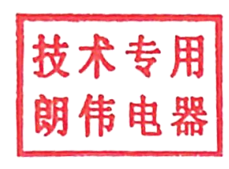
www.longwellfans.com

Model No.: | LWCA-30420SG-07-00
Version Number: | A0
Make : | ZHANG
Review : | YE
Approvd : | GUO
Date： | 20260810

Version number | Notes Remarks | Reason content | Revised by | Date

— 1 — NINGBO LONGWELL ELECTRIC TECHNOLOGY CO.,LTD
.
Phone: 0086 574 6218 9863 FAX : 0086 574 6218 9863 www.longwellfans .com sales@zjlongwell.com

LWCA-30420SG-07-00

CROSS FLOW FAN - AC Motor

Nominal Data

Project1 | Unit | Rating
Nominal Voltage : | [VAC] | 230
Voltage Range: | [VAC] | 198-242
Speed : | [rpm] | 2400
Power input : | [W] | 11
Air flow (Max) : | [m3/h] | 100
Air flow (Max) : | [CFM] | 59
Static pressure ( Max) : | [Pa] | 14
Noise level : | dB(A) | 28
Max.ambient Temp : | ℃ | 60
Min.ambient Temp : | ℃ | -25
Insulation Class： |  | Class F
Work system： |  | S1

NINGBO LONGWELL ELECTRIC TECHNOLOGY CO.,LTD

LWCA-30420SG-07-00
CROSS FLOW FAN - AC Motor

Technical Features

Material : | Aluminium ( Impeller )； cold-rolled sheet（frame）
Life expectancy： | 30,000Hours(L10)，At 25℃ room, humidity 30%~90%RH
Service environment : | Operating temperature：-30~60℃；Operating humidity： 0 ~ 90 % RH Storing temperature：-30~60℃；Storing humidity：0 ~ 80 % RH
Insulation Resistance： | /
Certification | CE
Bearing | Ball bearing

Noise Test

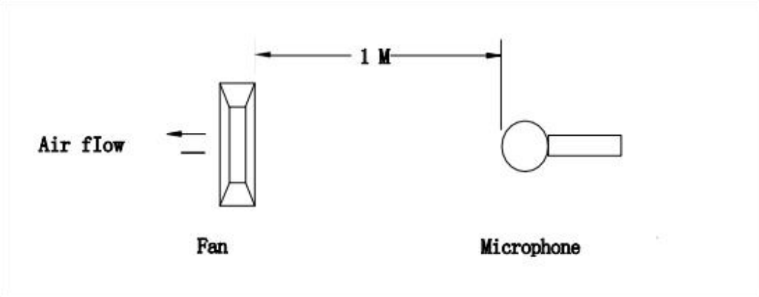
Noise is measured rated voltage in free air in an echoic chamber with B&K sound level meter with microphone at a distance of one meter from the fan intake.The background noise is 18Db(A) max.

— 3 — NINGBO LONGWELL ELECTRIC TECHNOLOGY CO.,LTD

CROSS FLOW FAN - AC Motor

LWCA-30420SG-07-00

Product Drawing

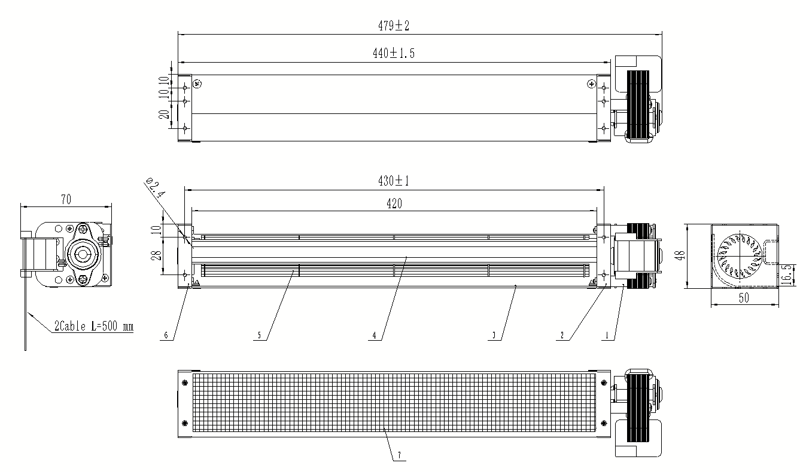

— 4 — NINGBO LONGWELL ELECTRIC TECHNOLOGY CO.,LTD

LWCA-30420SG-07-00
CROSS FLOW FAN - AC Motor

Wiring Diagram

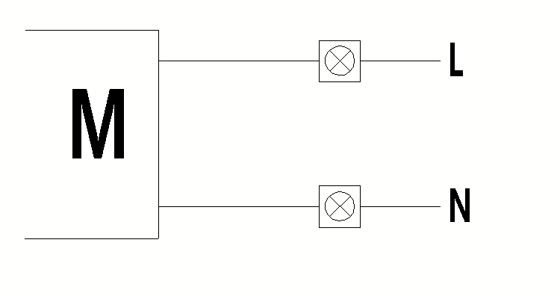

Label


Confirm by sales team when placing sample order or bulk order

— 5 — NINGBO LONGWELL ELECTRIC TECHNOLOGY CO.,LTD

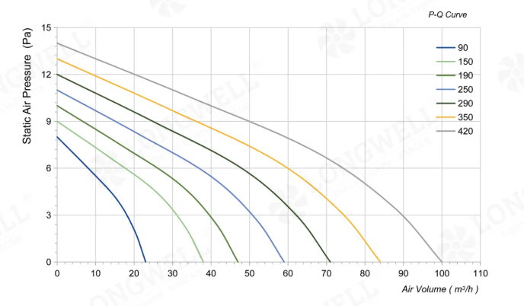
CROSS FLOW FAN - AC Motor

LWCA-30420SG-07-00

Charts :Air Flow

— 6 — NINGBO LONGWELL ELECTRIC TECHNOLOGY CO.,LTD

LWCA-30420SG-07-00
CROSS FLOW FAN - AC Motor

Warning:

1.Thefanand motormustbeusedwithintheprescribedscopeoftemperatureand humidity otherwiseit willcauseanunexpecteddamage.
2.Fanisnotsetwrongconnection protection ，Providetheright voltageandlinesequenceaccordingto thenameplateotherwiseitwilldamage theproduct.
3. Wiring depends on the wiring diagram and please connect the earth ground if required. We don't suggesttousetheextensioncord .Any wrongconnectionmay cause thedamageof thefan.
4. Be careful when moving the fan and do not take the blades as a handle because it will cause the distortionandchatter.
5. Connect the thermostat if required otherwise it would damage the motor because of the over
temperature.
6. The length of the mounting screws shall not exceed the requirement, otherwise the fan will be
damaged.
7.Donot disassemble the fanarbitrarily.It mayhurt thecapacityofwater tightnessand dynamicbalance orcauseotherserious problems.
8.Theover currentprotector isnecessaryincasethedamagefromtheovercurrent.
9.Installthefanasrequired,anyotherinstalling directionwould affecttheservicelifeoftheproduct.
10.Thefan withinletringshouldbeinstalledfollowtherequirementsorit willaffecttheperformance.
11.Usersshoulduse thestandardcablewheninstall thefan otherwiseitwillaffect the watertightness.
12.Thefanshouldkeepawayfrom thechildrenespeciallythebladeandelectricparts .Andthechildren arenotallowedto operatethe fanalone.
13. Do not connect the white signal cable directly to the red signal cable or the external DC power supply.Otherwise,thefanmaybe damaged.T
14.Pleasedonotperform extractionandinsertionoftheconnectorunderrevolutionirrespectiveof poweronandpoweronandpoweroff , andthe fanshouldnottouchormovewhenrunning.

15. Do not lift the fan wire when taking the fan, and do not impact the bearing during the handling
process.
16 The version change may not be notified, please ask our company for the latest version when
necessary.

17.Please be informed that we are not responsible for any damage or accidents caused by violating aboverulesto installandoperatethefan.

— 7 — NINGBO LONGWELL ELECTRIC TECHNOLOGY CO.,LTD

CROSS FLOW FAN - AC Motor

LWCA-30420SG-07-00

Approval

CUSTOMER APPROVAL

DATE :

CUSTOMER SIGNATURE:

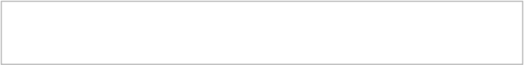
Product Data Confirm :



— 8 — NINGBO LONGWELL ELECTRIC TECHNOLOGY CO.,LTD

