Ningbo Longwell Electric Technology CO.,LTD
NO.100, Ditang District ,Yuyao,Zhejiang Province,China 315400
Phone 86 574 6218 9863
Fax 86 574 6218 9863
sales@zjlongwell.com
www.longwellfans.com

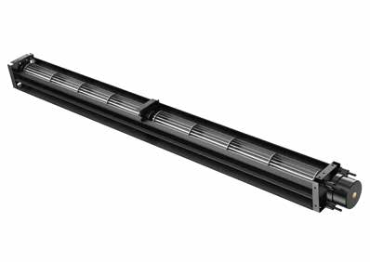

Model No.: | LWCD-30610MG-20
Version Number: | A0
Make : | Zhong
Review : | Jiang
Approvd : | Yao
Date： | 2023.12.23

Version number | Notes Remarks | Reason content | Revised by | Date



Nominal Data

Project1 | Unit | Rating
Nominal Voltage : | [VDC] | 24
Voltage Range: | [VDC] | 19-25
Initial voltage: | [VDC] | 14-16
Starting Voltage: | [VDC] | 19
Speed : | [rpm] | 0-2400
Current : | [A] | 0-0.19±10%
Power input : | [W] | 4.6
Air flow (Max) : | [m3/h] | 132
Air flow (Max) : | [CFM] | 78
Static pressure ( Max) : | [Pa] | 0-18
Noise level : | dB(A) | 33
Max.ambient Temp : | ℃ | 60
Min.ambient Temp : | ℃ | -25
Rotating Direction： |  | CCW

Technical Features

Material | Aluminium ( Impeller )； cold-rolled sheet（frame）
Life expectancy | 20,000Hours(L10)，At 25℃ room, humidity 30%~90%RH
Service environment | Operating temperature：-20~50℃；Operating humidity：0 ~ 90 % RH  Storing temperature：-25~60℃；Storing humidity：0 ~ 80 % RH
Insulation Resistance | /
Packing Vibration Test | After packing, 1.1G load is applied in XYZ three directions vibration test for  30min .No serious damage.
Packing Shock Proof Test | After bunching, the height is 30 cm, and 1 Angle, 3 sides and 6 sides fall naturally without serious damage bad.
Certification | CE
Bearing | Ball bearing

Speed Control : | PWM signal :frequency 1K~25HKZ,amplitude 5V,duty cycle 0 ~100
Speed Control : | Linear voltage:0-10V  When the effective value of control voltage is greater than 1.5V,the motor starts up ;when the effective value of control voltage is greater than 10±0.1V,the motor runs at the full speed ;when the fan is running ,if the effective value of control voltage is lower than 1.5V ; The motor stops.
Vibration of the fan : | Vibration speed virtual value of fans accord with JB/T8689
Other Features

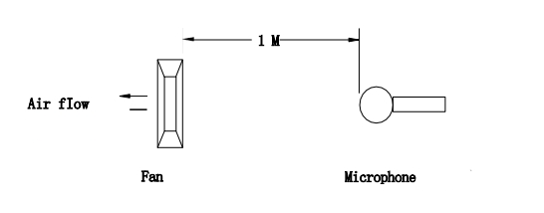
Noise Test
Noise is measured rated voltage in free air in an echoic chamber with B&K sound level meter with microphone at a distance of one meter from the fan intake.The background noise is 18Db(A) max.

The terminals are produced according to the same model as the customer's requirements
PS.As shown in the figure
Product Drawing

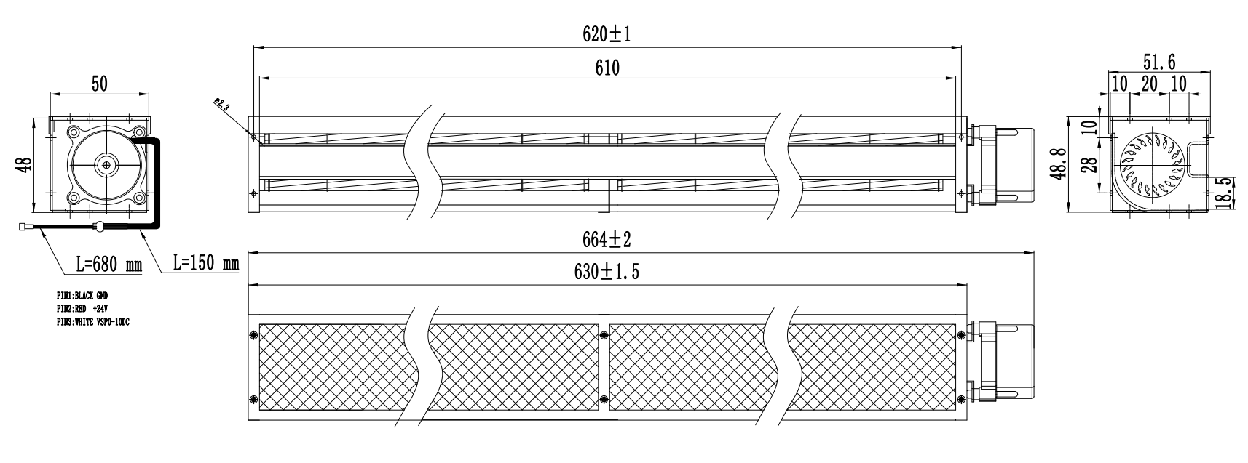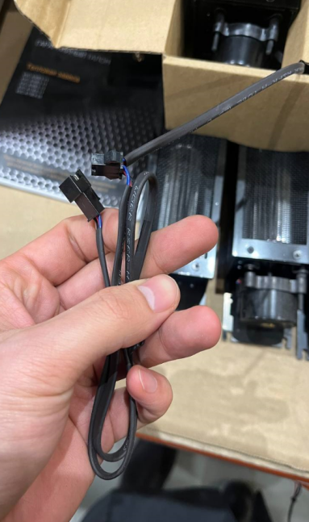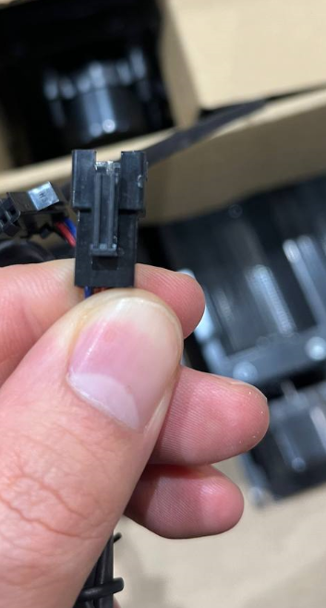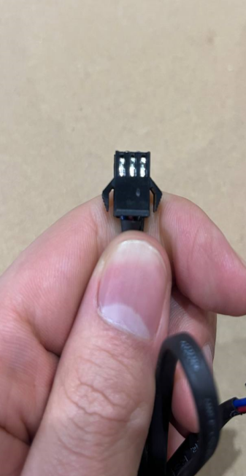

Wiring Diagram

Label

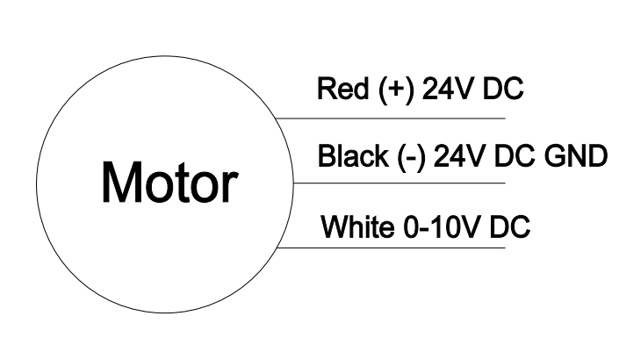

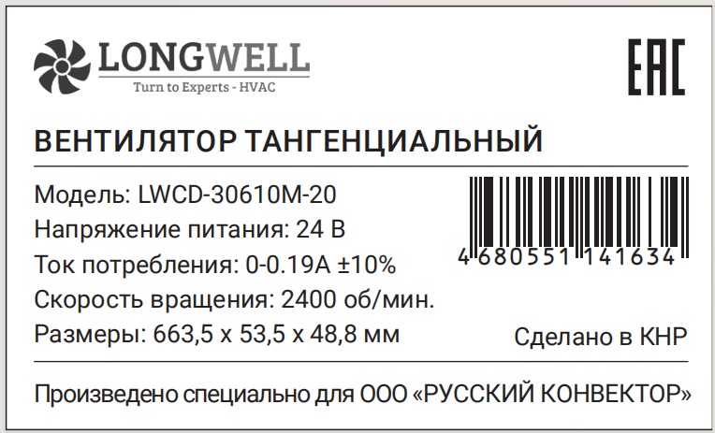

Charts :Air Flow

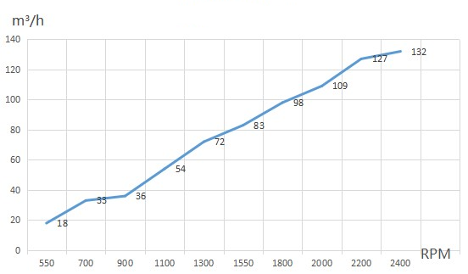

电流≦ mA不能用于***，上电顺序要求

Confirm by sales team when placing sample order or bulk order
Label

Warning:

1.The fan and motor must be used within the prescribed scope of temperature and humidity otherwise it will cause an unexpected damage.
2. Fan is not set wrong connection protection，Provide the right voltage and line sequence according to the nameplate otherwise it will damage the product.
3. Wiring depends on the wiring diagram and please connect the earth ground if required. We don't suggest to use the extension cord .Any wrong connection may cause the damage of the fan.
4. Be careful when moving the fan and do not take the blades as a handle because it will cause the distortion and chatter.
5. Connect the thermostat if required otherwise it would damage the motor because of the over temperature.
6. The length of the mounting screws shall not exceed the requirement, otherwise the fan will be damaged.
7. Do not disassemble the fan arbitrarily. It may hurt the capacity of water tightness and dynamic balance or cause other serious problems.
8. The over current protector is necessary in case the damage from the over current.
9. Install the fan as required, any other installing direction would affect the service life of the product.
10. The fan with inlet ring should be installed follow the requirements or it will affect the performance.
11. Users should use the standard cable when install the fan otherwise it will affect the water tightness.
12. The fan should keep away from the children especially the blade and electric parts .And the children are not allowed to operate the fan alone.
13. Do not connect the white signal cable directly to the red signal cable or the external DC power supply. Otherwise, the fan may be damaged.T
14.Please do not perform extraction and insertion of the connector under revolution irrespective of power on and power on and power off , and the fan should not touch or move when running.

15. Do not lift the fan wire when taking the fan, and do not impact the bearing during the handling process.
16. The version change may not be notified, please ask our company for the latest version when necessary.

17.Please be informed that we are not responsible for any damage or accidents caused by violating above rules to install and operate the fan.

Approval
Product Data Confirm :

DATE :

CUSTOMER SIGNATURE:

CUSTOMER APPROVAL

