CROSS FLOW FAN - DC Motor

LWCD-65520LG-06-00

Ningbo Longwell Electric Technology CO.,LTD
NO.100, Ditang District ,Yuyao,Zhejiang Province,China 315400 Phone 86 574 6218 9863
Fax 86 574 6218 9863
sales@zjlongwell.com

www.longwellfans.com

Model No.: | LWCD-65520LG-06-00
Version Number: | A0
Make : | ZHANG
Review : | YE
Approvd : | GUO
Date： | 20260813

Version number | Notes Remarks | Reason content | Revised by | Date

— 1 — NINGBO LONGWELL ELECTRIC TECHNOLOGY CO.,LTD
.
Phone: 0086 574 6218 9863 FAX : 0086 574 6218 9863 www.longwellfans .com sales@zjlongwell.com

CROSS FLOW FAN - DC Motor
LWCD-65520LG-06-00

Nominal Data

Project1 | Unit | Rating
Nominal Voltage : | [VDC] | 12
Voltage Range: | [VDC] | 9~16
Speed : | [rpm] | 1800±5%
Current : | [A] | 2.7 ±10%
Power input : | [W] | /
Air flow (Max) : | [m3/h] | 606
Air flow (Max) : | [CFM] | 357
Static pressure ( Max) : | [Pa] | 52
Noise level : | dB(A) | 53
Max.ambient Temp : | ℃ | 60
Min.ambient Temp : | ℃ | -25
Rotating Direction： |  | CCW

Technical Features

Production Reference Standard | GB12350《 Safety requirements of small power motors》  JB/T10563 《technical specification for general purposes centrifugal fans》 EN60335-1《 Household and similar electrical appliances-safety》  ISO5801-1997《 Industrial fans-performance testing using standardized airways》  GB/T2888《 Methods of Noise Measurement for Fans Blowers Compressors and Roots Blowers》
Certification | CE
Environmental Protection | RoHS 、Reach
— 2 — NINGBO LONGWELL ELECTRIC TECHNOLOGY CO.,LTD

CROSS FLOW FAN - DC Motor
LWCD-65520LG-06-00

Technical Features

Service Environment | Operating temperature：-25~60℃；Operating humidity：5 ~ 90 % RH Storing temperature：-25 ~ 60℃；Storing humidity： ≤95 % RH  Applicable altitude range：＜1000m
Life Expectance | 40,000Hours(L10)，At 25℃ room, humidity 15%~65%RH.
Balancing | According to JB/T 9101-1999 requirements G6.3
Vibration of The Fan | Test method accord with JB/T 8689
Installation Method | Horizontal or vertical installation
Material | Aluminium( Impeller ) The whole machine is electrophoresis
Bearing | Maintenance-free deep groove ball bearings
Weight | APPROX / (Kg)

Electrical Protection

Speed Control | Control input 0~ 10VDC
VSP Control | Control signal VSP voltage range1VDC~10VDC  (During normal operation, when the VSP voltage is below 1.2VDC, the motor switches from operating mode to standby mode)
PWM Control | PWM signal: frequency 1K～10KHz, amplitude 10V,duty cycle 10% ～100% .
Signal Output | Tach output：2 Pulse/R；FG internal open circuit output, external pull-up resistor R, pull-up voltage V+
Serial Communication | /

— 3 — NINGBO LONGWELL ELECTRIC TECHNOLOGY CO.,LTD

CROSS FLOW FAN - DC Motor
LWCD-65520LG-06-00

Noise Test

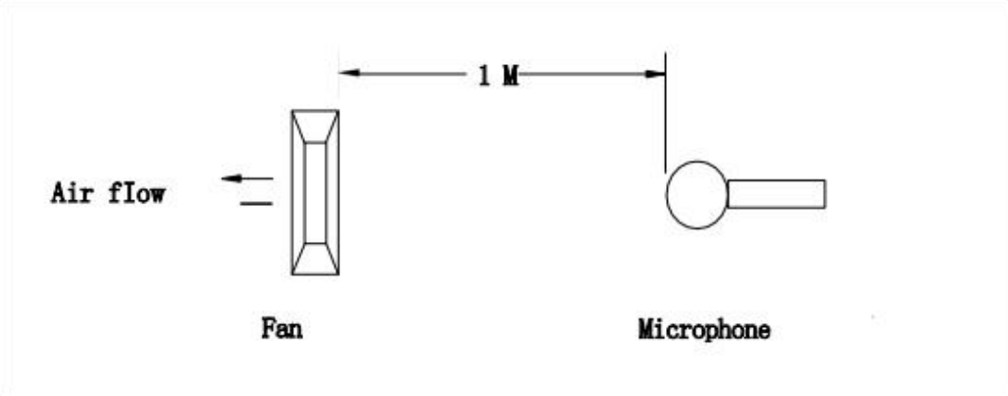

Noise is measured rated voltage in free air in an echoic chamber with B&K sound level meter with microphone at a distance of one meter from the fan intake.The background noise is 18Db(A) max.

— 4 — NINGBO LONGWELL ELECTRIC TECHNOLOGY CO.,LTD

CROSS FLOW FAN - DC Motor

LWCD-65520LG-06-00

Product Drawing

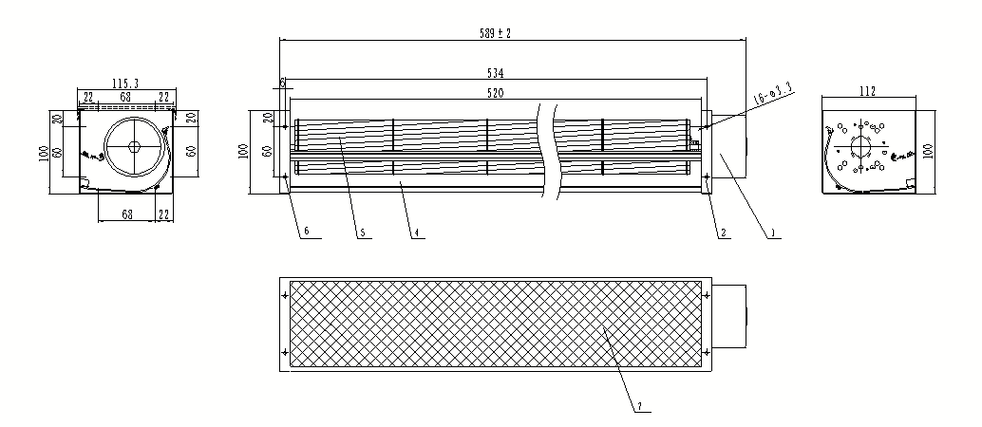

— 5 — NINGBO LONGWELL ELECTRIC TECHNOLOGY CO.,LTD

CROSS FLOW FAN - DC Motor
LWCD-65520LG-06-00

Wiring Diagram

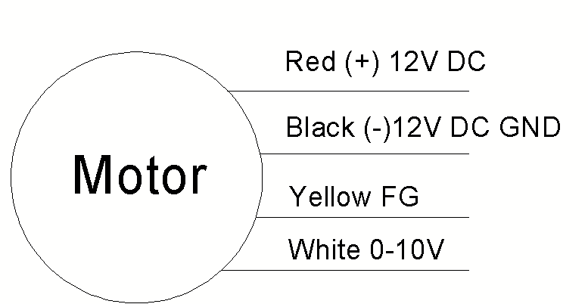

Label



Confirm by sales team when placing sample order or bulk order

— 6 — NINGBO LONGWELL ELECTRIC TECHNOLOGY CO.,LTD

CROSS FLOW FAN - DC Motor
LWCD-65520LG-06-00

Warning:

1.Thefanand motormustbeusedwithintheprescribedscopeoftemperatureand humidity otherwiseit willcauseanunexpecteddamage.
2.Fanisnotsetwrongconnection protection ，Providetheright voltageandlinesequenceaccordingto thenameplateotherwiseitwilldamage theproduct.
3. Wiring depends on the wiring diagram and please connect the earth ground if required. We don't suggesttousetheextensioncord .Any wrongconnectionmay cause thedamageof thefan.
4. Be careful when moving the fan and do not take the blades as a handle because it will cause the distortionandchatter.
5. Connect the thermostat if required otherwise it would damage the motor because of the over
temperature.
6. The length of the mounting screws shall not exceed the requirement, otherwise the fan will be
damaged.
7.Donot disassemble the fanarbitrarily.It mayhurt thecapacityofwater tightnessand dynamicbalance orcauseotherserious problems.
8.Theover currentprotector isnecessaryincasethedamagefromtheovercurrent.
9.Installthefanasrequired,anyotherinstalling directionwould affecttheservicelifeoftheproduct.
10.Thefan withinletringshouldbeinstalledfollowtherequirementsorit willaffecttheperformance.
11.Usersshoulduse thestandardcablewheninstall thefan otherwiseitwillaffect the watertightness.
12.Thefanshouldkeepawayfrom thechildrenespeciallythebladeandelectricparts .Andthechildren arenotallowedto operatethe fanalone.
13. Do not connect the white signal cable directly to the red signal cable or the external DC power supply.Otherwise,thefanmaybe damaged.T
14.Pleasedonotperform extractionandinsertionoftheconnectorunderrevolutionirrespectiveof poweronandpoweronandpoweroff , andthe fanshouldnottouchormovewhenrunning.

15. Do not lift the fan wire when taking the fan, and do not impact the bearing during the handling
process.
16 The version change may not be notified, please ask our company for the latest version when
necessary.

17.Please be informed that we are not responsible for any damage or accidents caused by violating aboverulesto installandoperatethefan.

— 8 — NINGBO LONGWELL ELECTRIC TECHNOLOGY CO.,LTD

CROSS FLOW FAN - DC Motor

LWCD-65520LG-06-00
Approval

CUSTOMER APPROVAL

DATE :

CUSTOMER SIGNATURE:


Product Data Confirm :



— 9 — NINGBO LONGWELL ELECTRIC TECHNOLOGY CO.,LTD

