EC 贯流风机

LWCE-80520SN-06-00

Ningbo Longwell Electric Technology CO.,LTD
NO.100, Ditang District ,Yuyao,Zhejiang Province,China 315400 Phone 86 574 6218 9863
Fax 86 574 6218 9863
sales@zjlongwell.com

www.longwellfans.com

型号: | LWCE-80520SN-06-00
版本号: | A0
设计 : | 张
审核 : | 郭
批准 : | 叶
时间： | 20260811

版本号 | 备注 | 变更原因 | 变更人 | 时间

— 1 — NINGBO LONGWELL ELECTRIC TECHNOLOGY CO.,LTD
.
Phone: 0086 574 6218 9863 FAX : 0086 574 6218 9863 www.longwellfans .com sales@zjlongwell.com

LWCE-80520SN-06-00
EC 贯流风机

Nominal Data

类型 | 单位 | 数值
电压: | [VAC] | 230
电压范围: | [VAC] | 184-276
频率： | [HZ] | 50/60
转数 : | [rpm] | 1500
输入功率 : | [W] | /
最大风量 : | [m3/h] | 650
最大风量 : | [CFM] | 382
最大静压: | [Pa] | 59
噪音 : | dB(A) | 53
最高使用温度 : | ℃ | 60
最低使用温度 : | ℃ | -25
旋向： |  | CCW

— 2 — NINGBO LONGWELL ELECTRIC TECHNOLOGY CO.,LTD

LWCE-80520SN-06-00

EC 贯流风机

Technical Features

材料 : | 铝(叶轮);冷轧钢板(框架)
使用寿命： | 30,000 小时(L10)，在 25°C 室温下，湿度 30%~90%RH
服务环境 : | 工作温度:-25~60°C;工作湿度:0~90%RH  存储温度:-30~60°C;存储湿度:0~80%RH
绝缘电阻： | /
认证： | CE
轴承 | 滚珠轴承

噪音测试

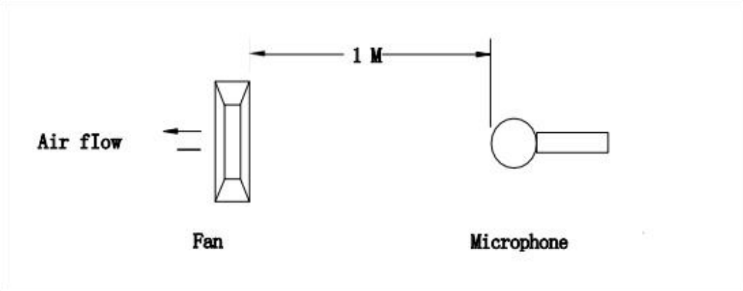
在回声室中，使用 B&K 声级计和麦克风，在距离风扇进风口一米处测量自由空气中的额定电压噪声 。背景噪声最大为:18dB(A).

— 3 — NINGBO LONGWELL ELECTRIC TECHNOLOGY CO.,LTD

EC 贯流风机

LWCE-80520SN-06-00

图纸

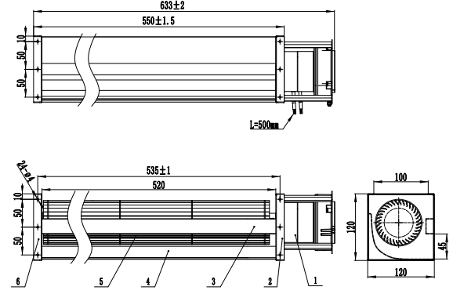

— 4 — NINGBO LONGWELL ELECTRIC TECHNOLOGY CO.,LTD

LWCE-80520SN-06-00

EC 贯流风机

接线图

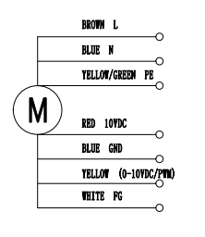

标贴


在下样品订单或批量订单时，由销售团队确认。

— 5 — NINGBO LONGWELL ELECTRIC TECHNOLOGY CO.,LTD

LWCE-80520SN-06-00

EC 贯流风机

P-Q 曲线
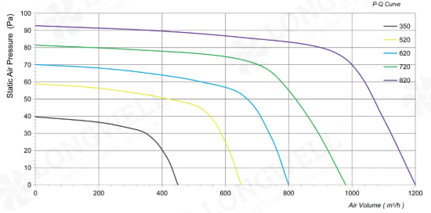

— 6 — NINGBO LONGWELL ELECTRIC TECHNOLOGY CO.,LTD

LWCE-80520SN-06-00

EC 贯流风机

Warning:

1.Thefanand motormustbeusedwithintheprescribedscopeoftemperatureand humidity otherwiseit willcauseanunexpecteddamage.
2.Fanisnotsetwrongconnection protection ，Providetheright voltageandlinesequenceaccordingto thenameplateotherwiseitwilldamage theproduct.
3. Wiring depends on the wiring diagram and please connect the earth ground if required. We don't suggesttousetheextensioncord .Any wrongconnectionmay cause thedamageof thefan.
4. Be careful when moving the fan and do not take the blades as a handle because it will cause the distortionandchatter.
5. Connect the thermostat if required otherwise it would damage the motor because of the over
temperature.
6. The length of the mounting screws shall not exceed the requirement, otherwise the fan will be
damaged.
7.Donot disassemble the fanarbitrarily.It mayhurt thecapacityofwater tightnessand dynamicbalance orcauseotherserious problems.
8.Theover currentprotector isnecessaryincasethedamagefromtheovercurrent.
9.Installthefanasrequired,anyotherinstalling directionwould affecttheservicelifeoftheproduct.
10.Thefan withinletringshouldbeinstalledfollowtherequirementsorit willaffecttheperformance.
11.Usersshoulduse thestandardcablewheninstall thefan otherwiseitwillaffect the watertightness.
12.Thefanshouldkeepawayfrom thechildrenespeciallythebladeandelectricparts .Andthechildren arenotallowedto operatethe fanalone.
13. Do not connect the white signal cable directly to the red signal cable or the external DC power supply.Otherwise,thefanmaybe damaged.T
14.Pleasedonotperform extractionandinsertionoftheconnectorunderrevolutionirrespectiveof poweronandpoweronandpoweroff , andthe fanshouldnottouchormovewhenrunning.

15. Do not lift the fan wire when taking the fan, and do not impact the bearing during the handling
process.
16 The version change may not be notified, please ask our company for the latest version when
necessary.

17.Please be informed that we are not responsible for any damage or accidents caused by violating aboverulesto installandoperatethefan.

— 7 — NINGBO LONGWELL ELECTRIC TECHNOLOGY CO.,LTD

EC 贯流风机

LWCE-80520SN-06-00
Approval

CUSTOMER APPROVAL

DATE :

CUSTOMER SIGNATURE:


Product Data Confirm :



— 8 — NINGBO LONGWELL ELECTRIC TECHNOLOGY CO.,LTD

